QUALITY CONTROL

DATE : 02-01-2026

|  |  |  |  |  |  |  |  |  |  |  |  |
| --- | --- | --- | --- | --- | --- | --- | --- | --- | --- | --- | --- |
| Box Id | Soft | Wound | Bruise | Stain | Cracking | No Stem | Pitting | Decay | Avg Brix | Open | Firmness |
| 30944504 | 0 % | 1 % | 0 % | 0 % | 3 % | 13 % | 8 % | 0 % | 18.840000 | GOOD | GOOD |

Open

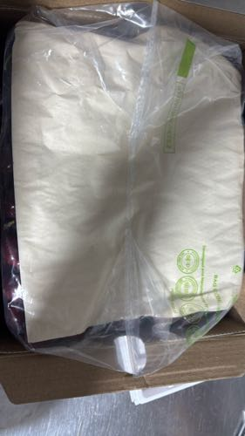 | 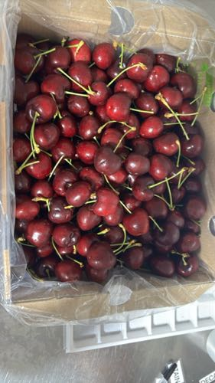 | 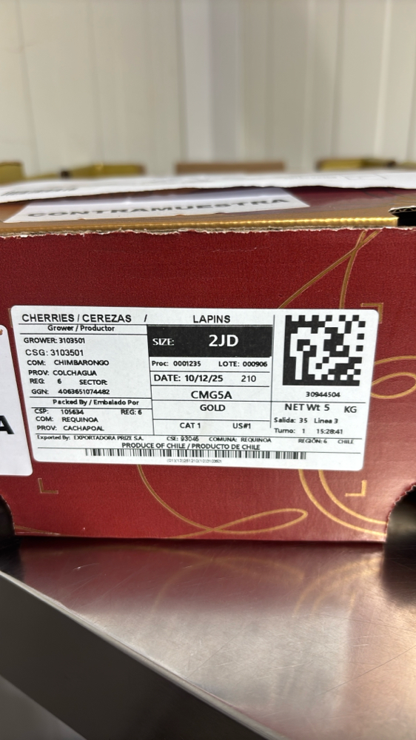

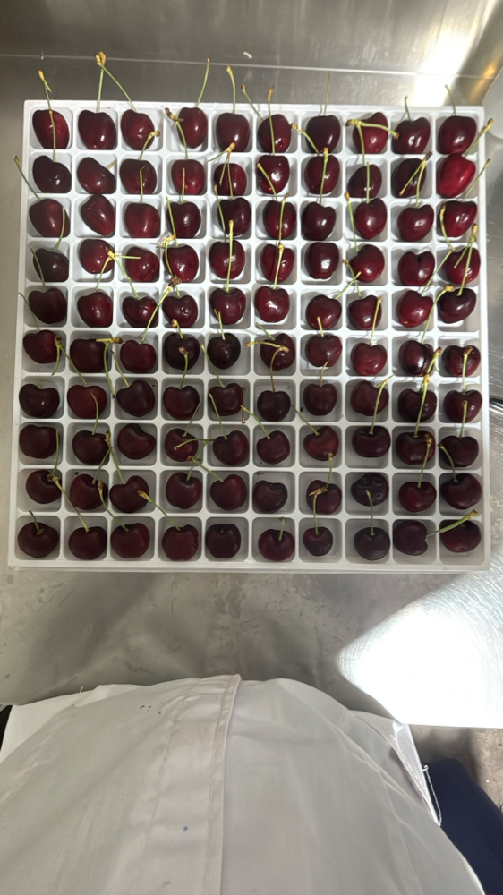 | 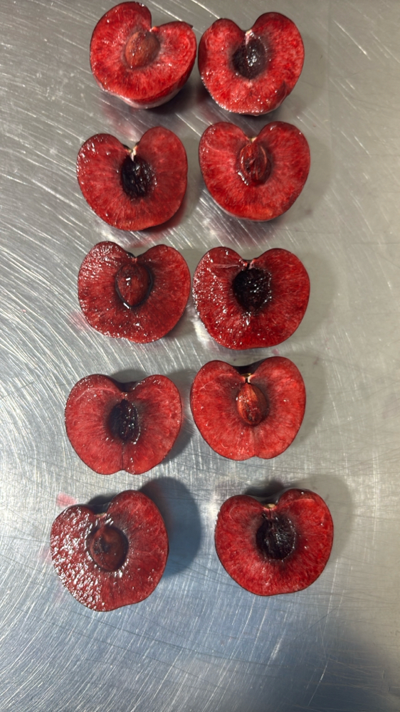 | 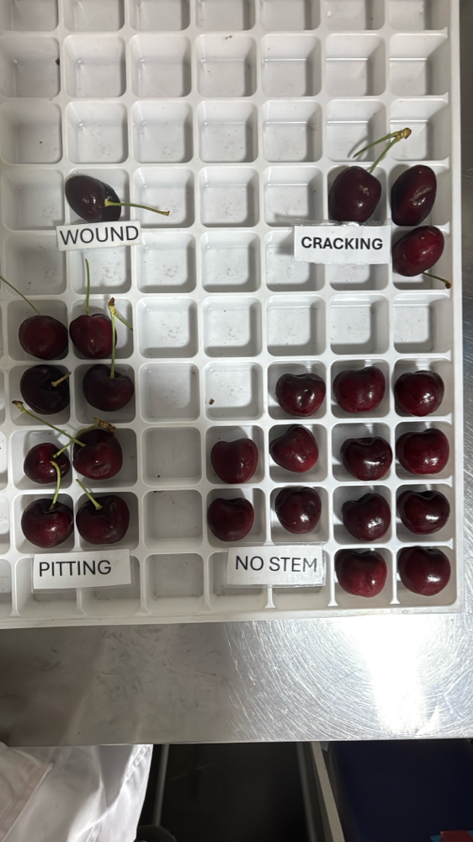 | 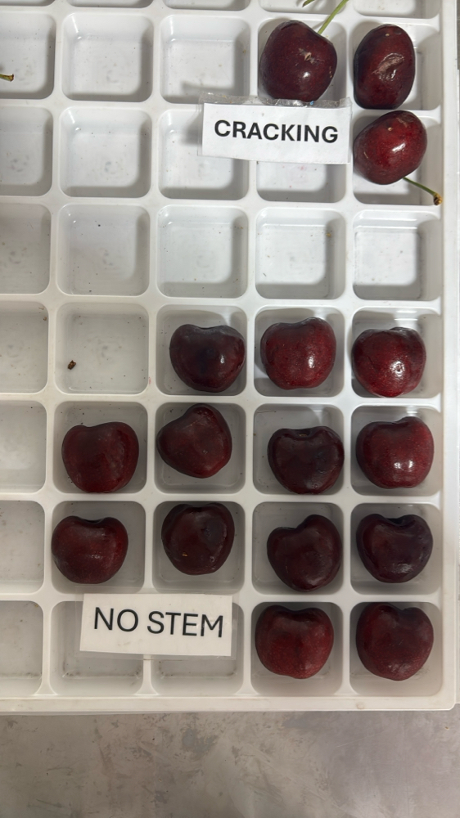

|  |  |  |  |  |  |  |  |  |  |  |  |
| --- | --- | --- | --- | --- | --- | --- | --- | --- | --- | --- | --- |
| Box Id | Soft | Wound | Bruise | Stain | Cracking | No Stem | Pitting | Decay | Avg Brix | Open | Firmness |
| 40832700 | 0 % | 0 % | 2 % | 0 % | 2 % | 4 % | 9 % | 0 % | 18.400000 | GOOD | GOOD |

Open

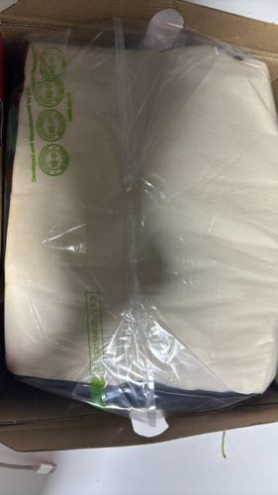 | 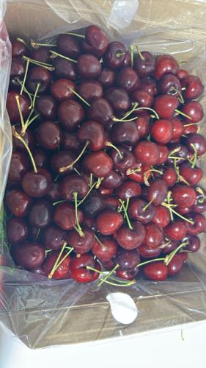 | 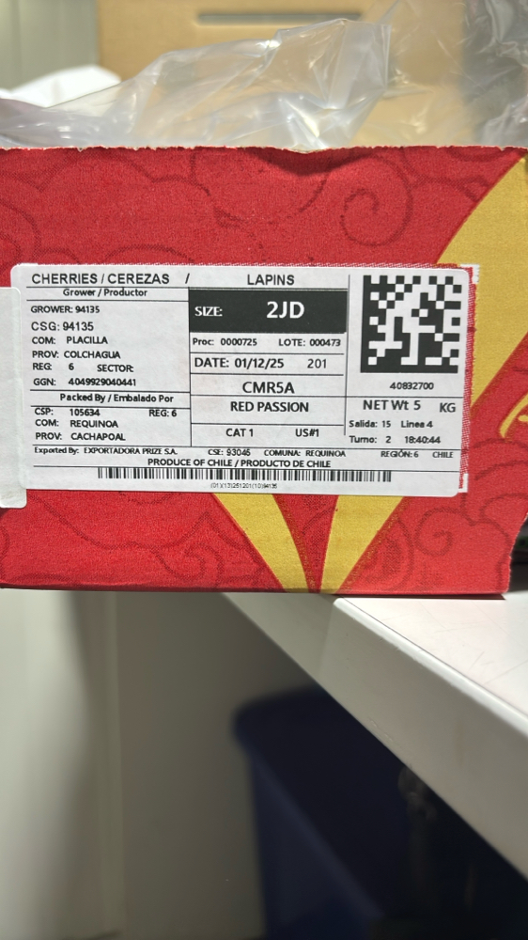

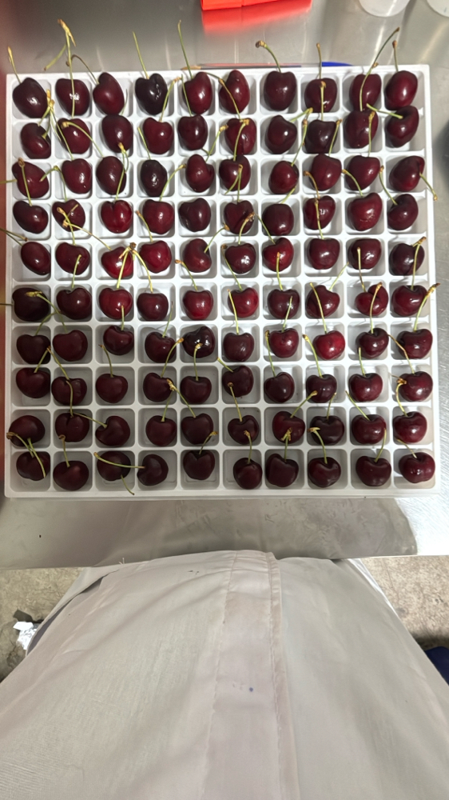 | 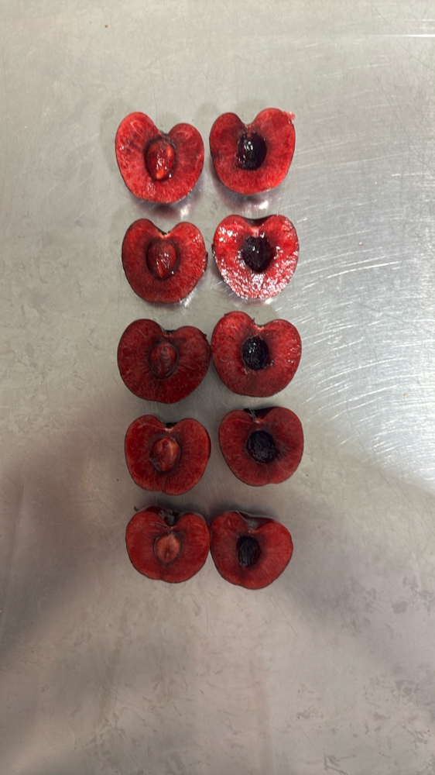 | 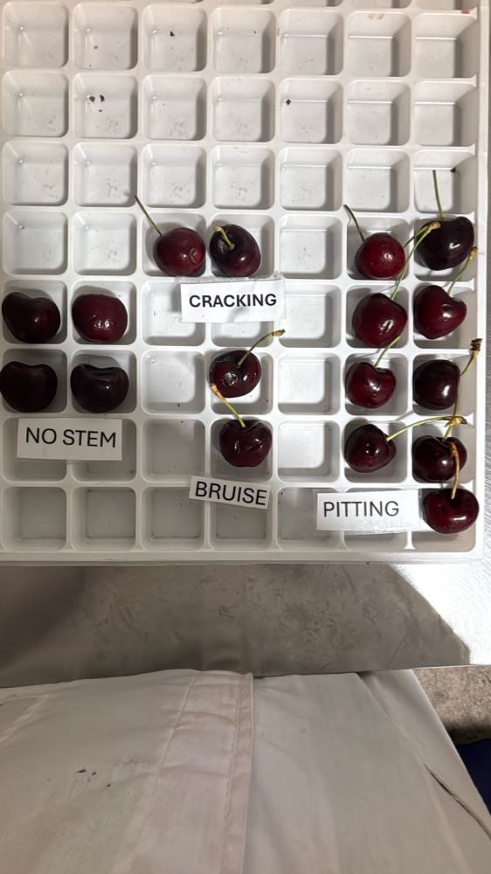 | 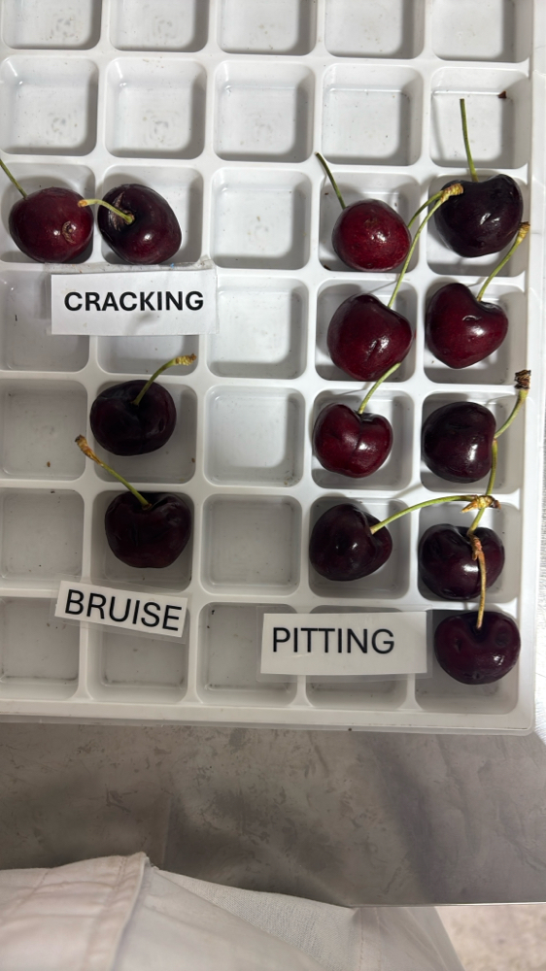

|  |  |  |  |  |  |  |  |  |  |  |  |
| --- | --- | --- | --- | --- | --- | --- | --- | --- | --- | --- | --- |
| Box Id | Soft | Wound | Bruise | Stain | Cracking | No Stem | Pitting | Decay | Avg Brix | Open | Firmness |
| 40835236 | 0 % | 0 % | 8 % | 0 % | 7 % | 5 % | 20 % | 1 % | 16.720000 | GOOD | GOOD |

Open

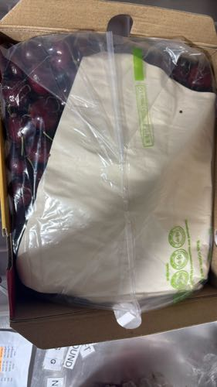 | 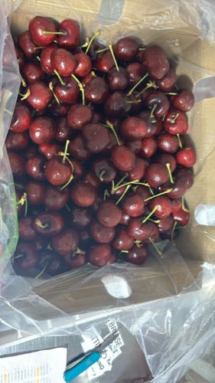 | 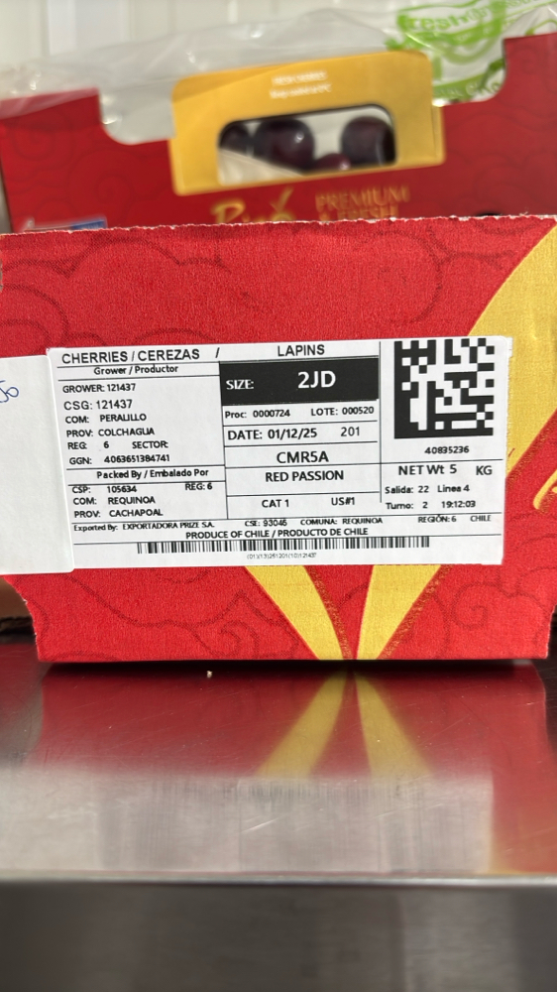

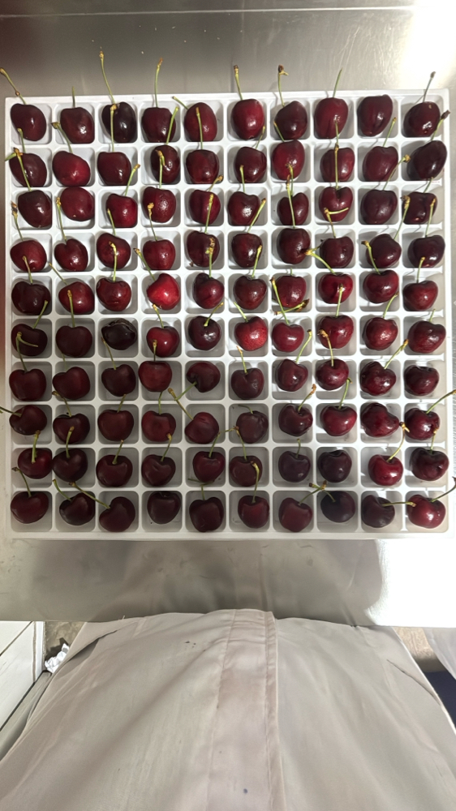 | 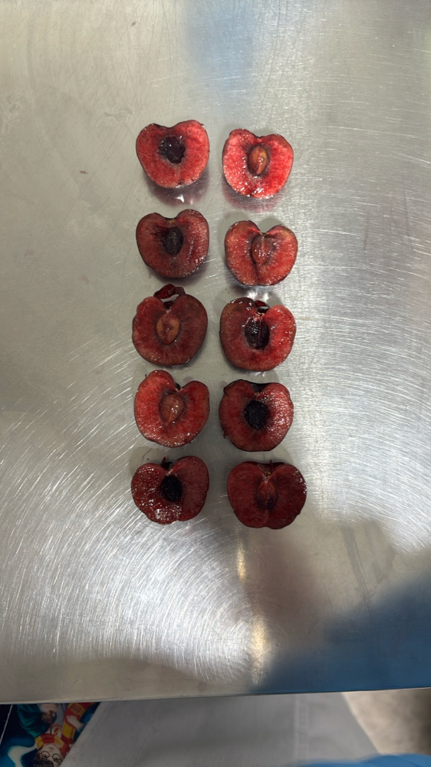 | 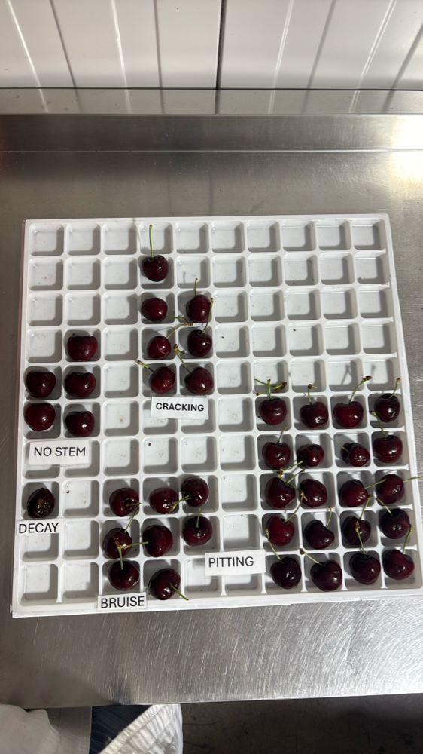 | 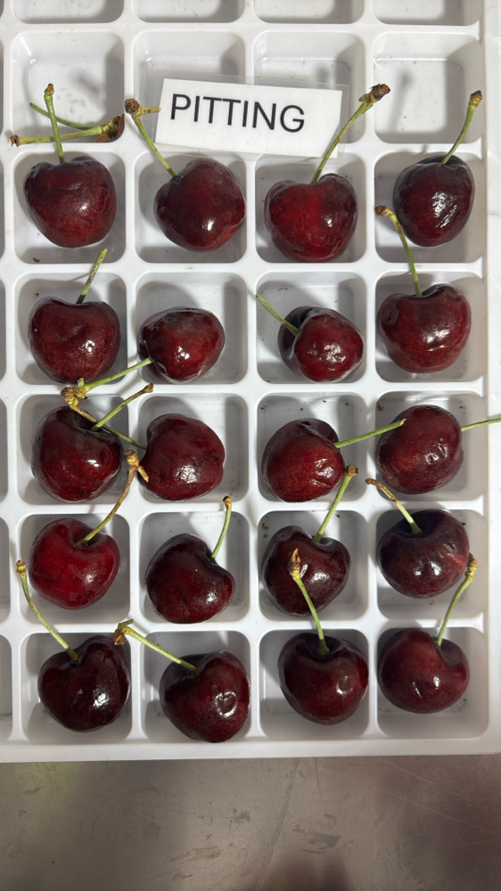

|  |  |  |  |  |  |  |  |  |  |  |  |
| --- | --- | --- | --- | --- | --- | --- | --- | --- | --- | --- | --- |
| Box Id | Soft | Wound | Bruise | Stain | Cracking | No Stem | Pitting | Decay | Avg Brix | Open | Firmness |
| 41177188 | 0 % | 0 % | 1 % | 0 % | 2 % | 10 % | 11 % | 0 % | 20.120000 | GOOD | GOOD |

Open

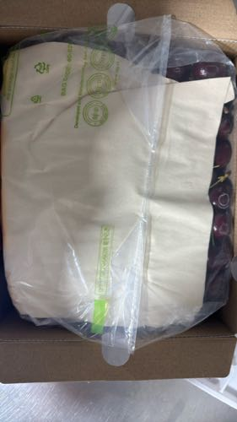 | 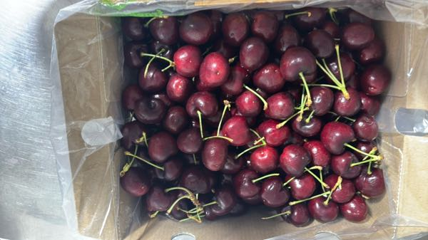 | 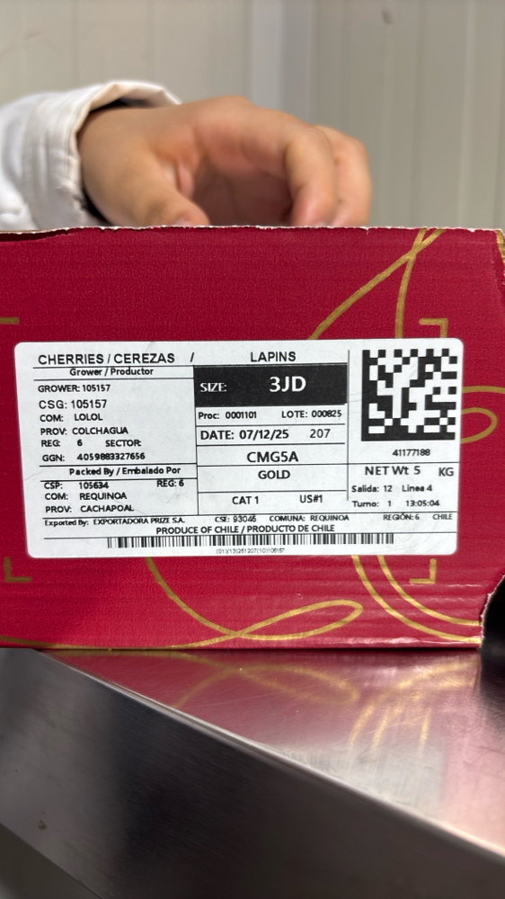

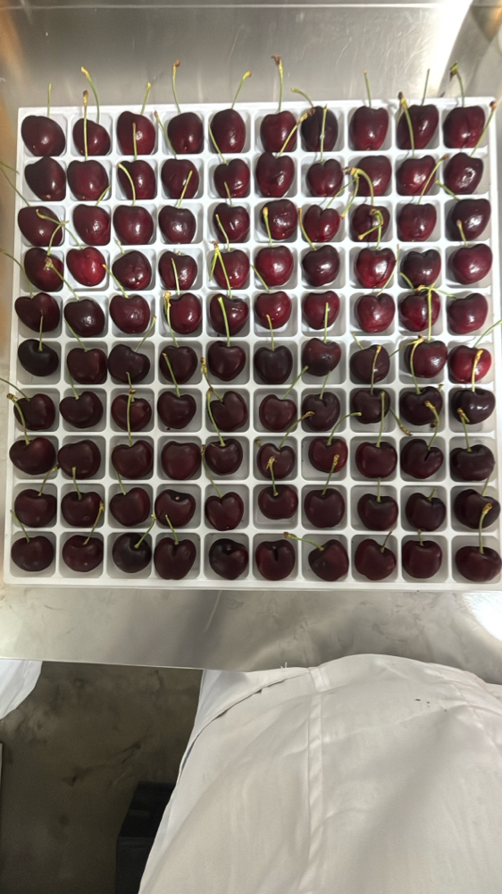 | 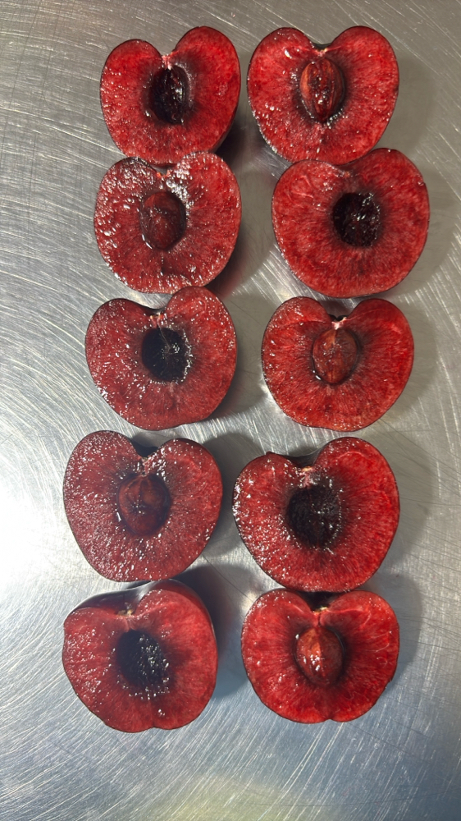 | 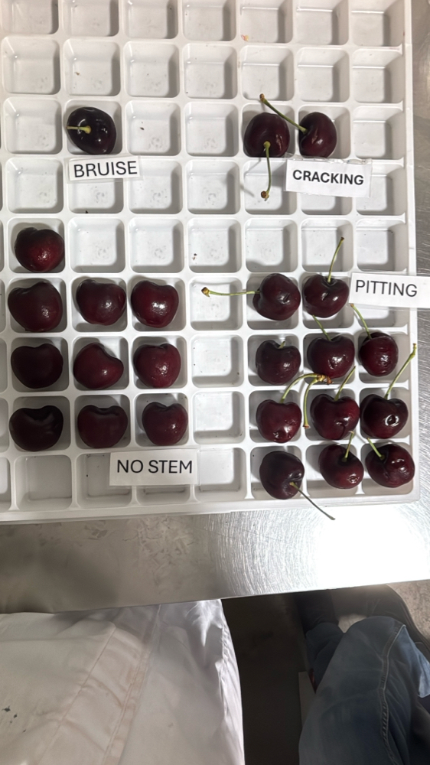 | 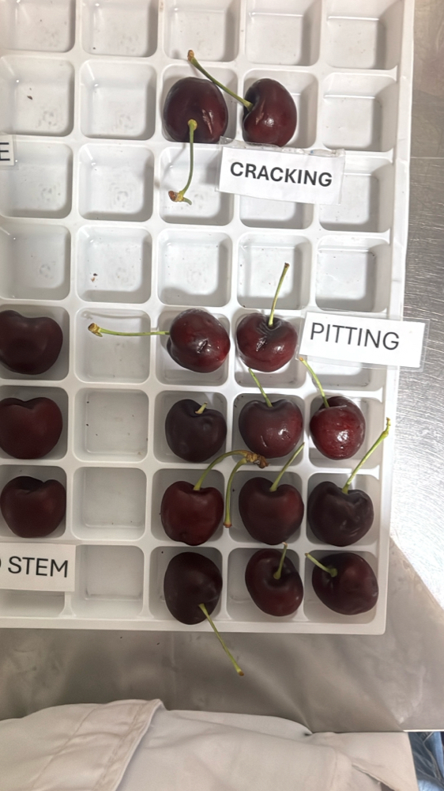

|  |  |  |  |  |  |  |  |  |  |  |  |
| --- | --- | --- | --- | --- | --- | --- | --- | --- | --- | --- | --- |
| Box Id | Soft | Wound | Bruise | Stain | Cracking | No Stem | Pitting | Decay | Avg Brix | Open | Firmness |
| 40982095 | 0 % | 0 % | 0 % | 0 % | 0 % | 11 % | 11 % | 0 % | 19.600000 | GOOD | GOOD |

Open

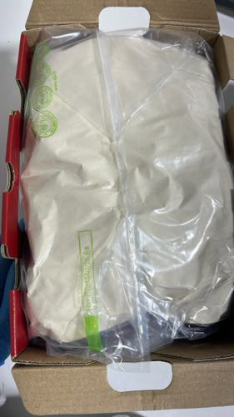 | 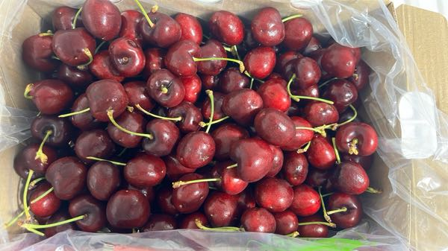 | 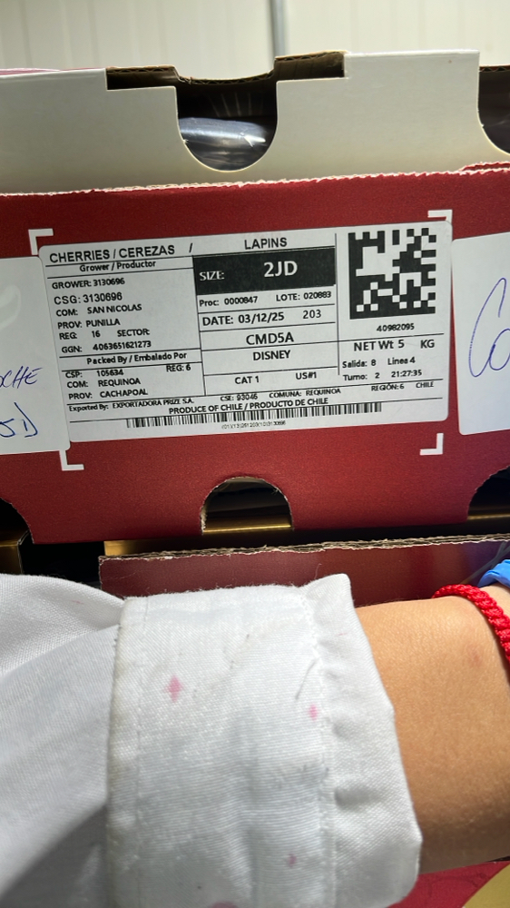

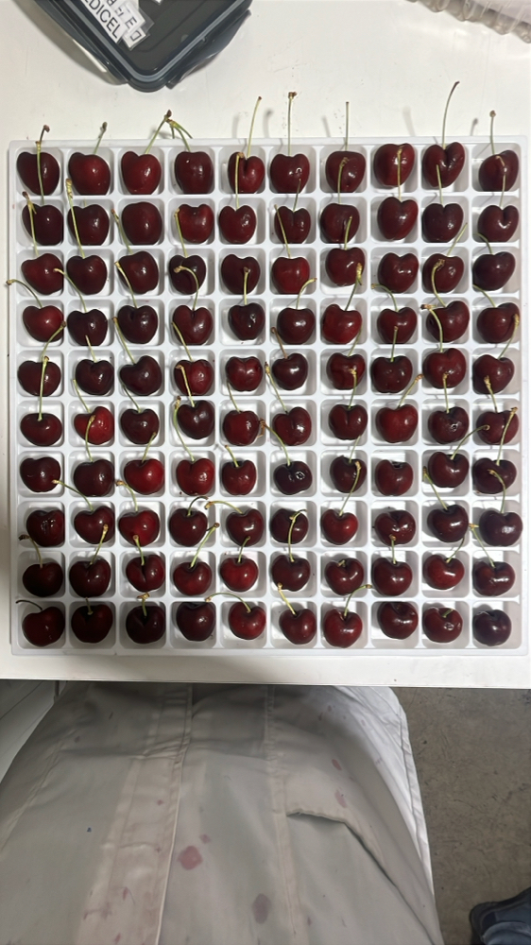 | 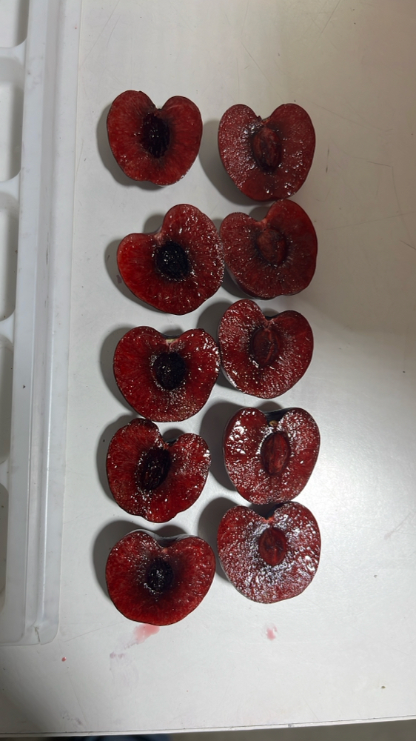 | 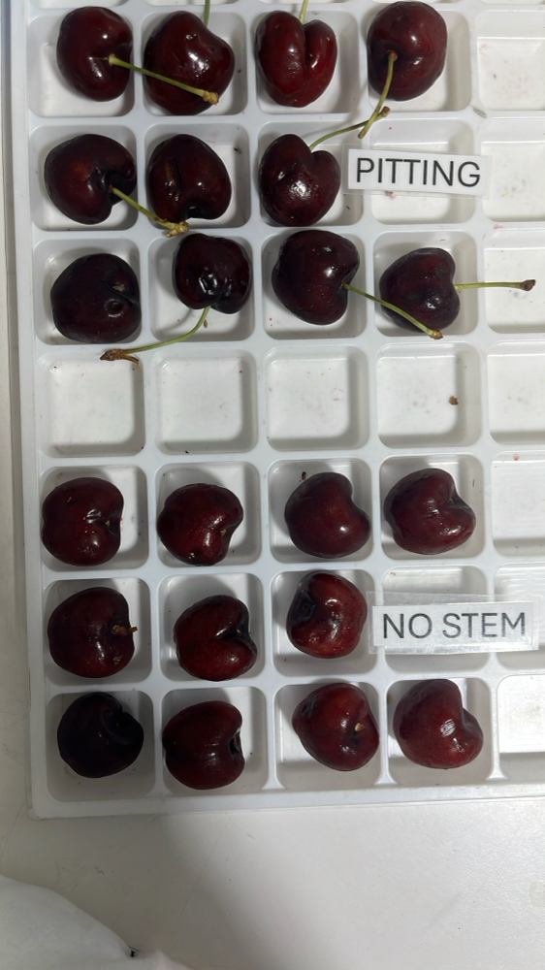 | 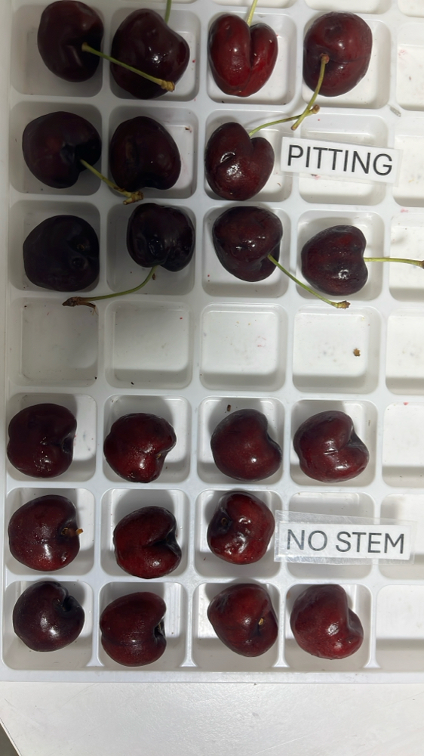

|  |  |  |  |  |  |  |  |  |  |  |  |
| --- | --- | --- | --- | --- | --- | --- | --- | --- | --- | --- | --- |
| Box Id | Soft | Wound | Bruise | Stain | Cracking | No Stem | Pitting | Decay | Avg Brix | Open | Firmness |
| 41132999 | 17 % | 1 % | 0 % | 0 % | 0 % | 7 % | 15 % | 0 % | 15.960000 | GOOD | FAIR |

Open

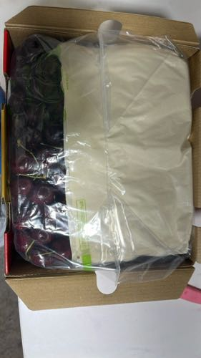 | 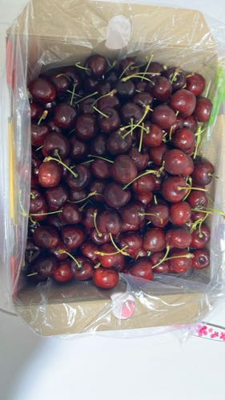 | 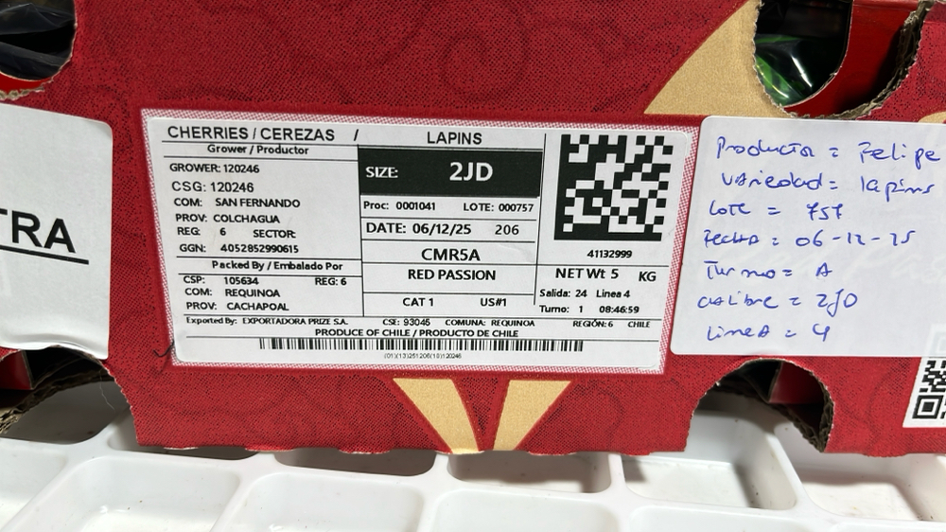

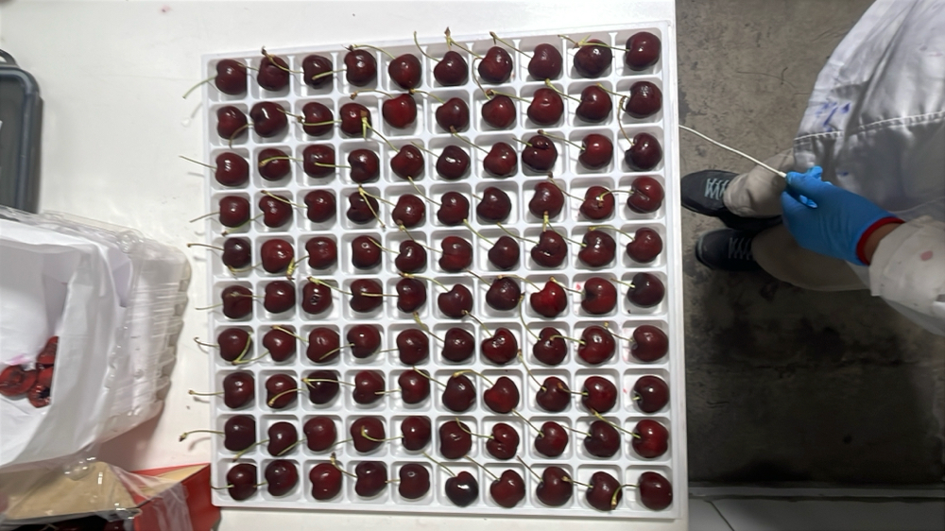 | 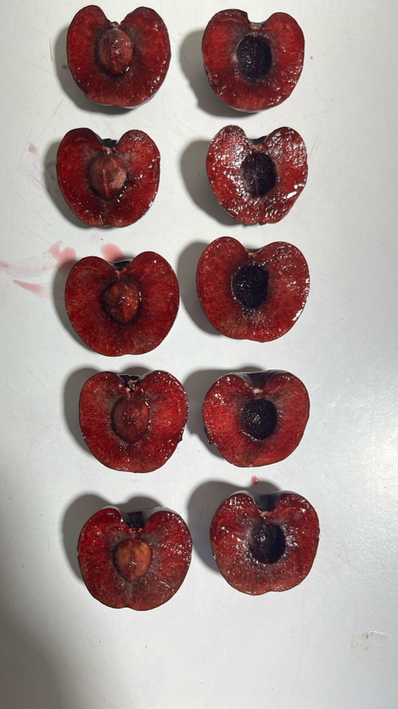 | 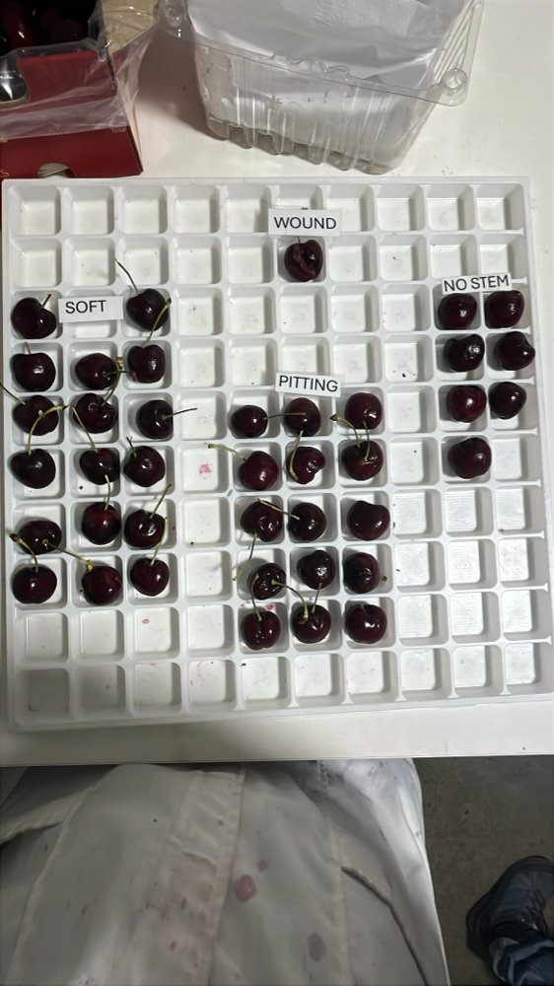 | 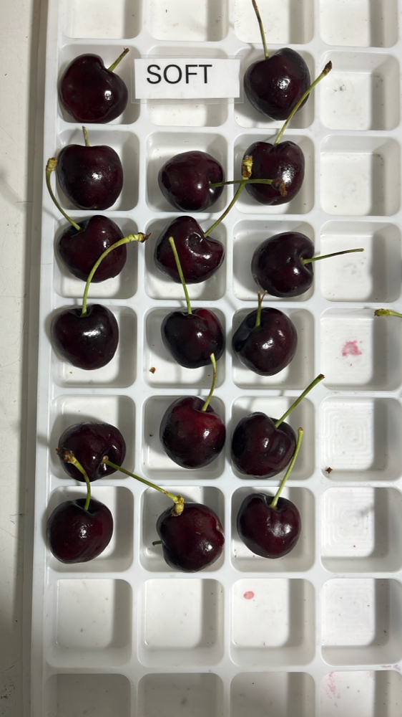

|  |  |  |  |  |  |  |  |  |  |  |  |
| --- | --- | --- | --- | --- | --- | --- | --- | --- | --- | --- | --- |
| Box Id | Soft | Wound | Bruise | Stain | Cracking | No Stem | Pitting | Decay | Avg Brix | Open | Firmness |
| 40979582 | 1 % | 3 % | 0 % | 0 % | 0 % | 3 % | 12 % | 0 % | 21.200000 | GOOD | GOOD |

Open

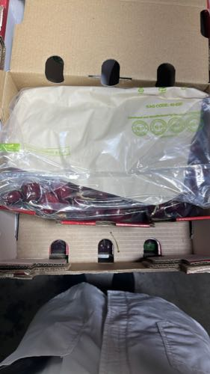 | 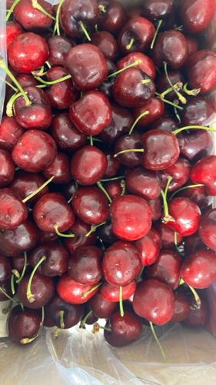 | 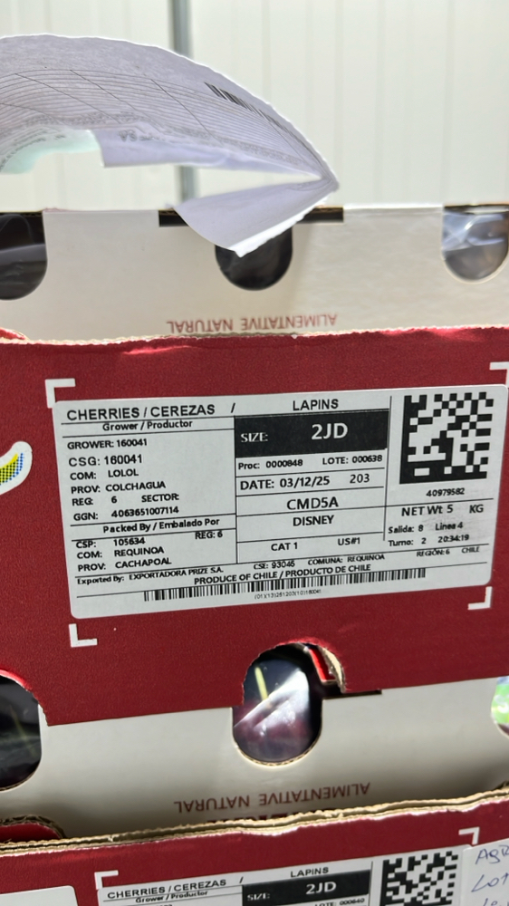

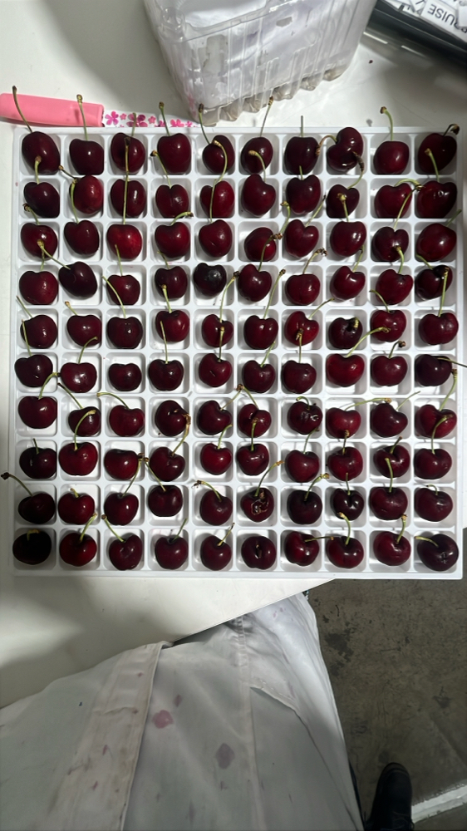 | 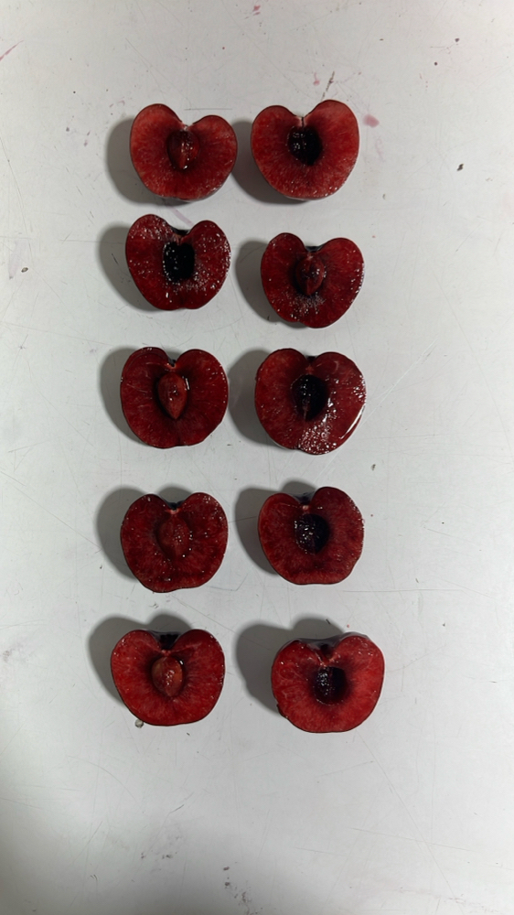 | 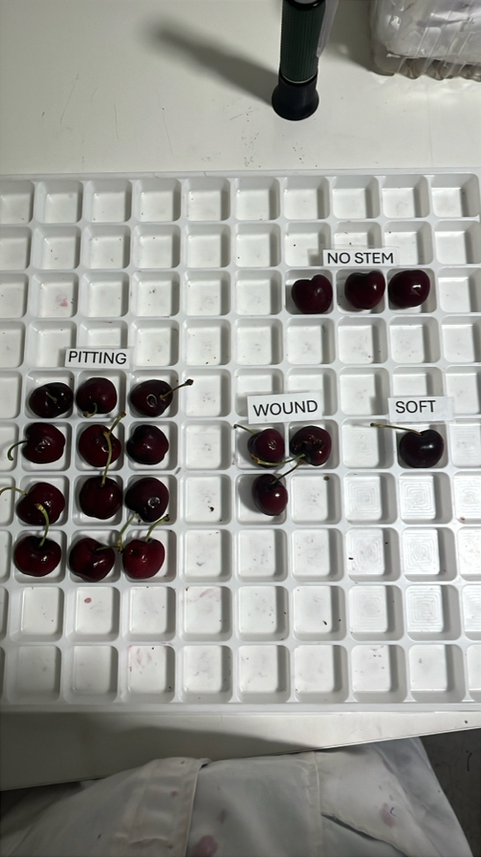 | 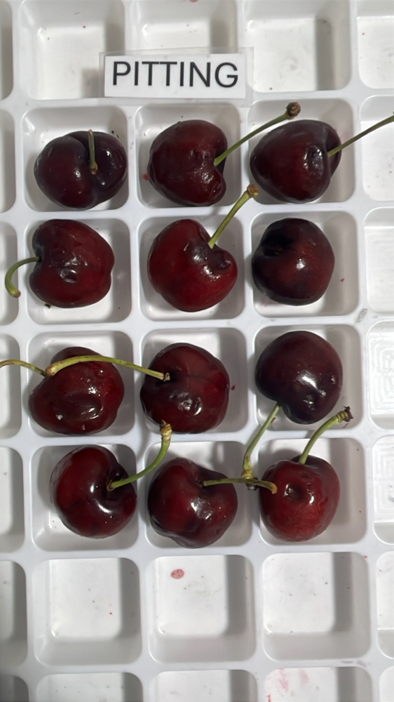

|  |  |  |  |  |  |  |  |  |  |  |  |
| --- | --- | --- | --- | --- | --- | --- | --- | --- | --- | --- | --- |
| Box Id | Soft | Wound | Bruise | Stain | Cracking | No Stem | Pitting | Decay | Avg Brix | Open | Firmness |
| 30475323 | 0 % | 3 % | 14 % | 0 % | 3 % | 1 % | 17 % | 0 % | 17.560000 | FAIR | GOOD |

Open

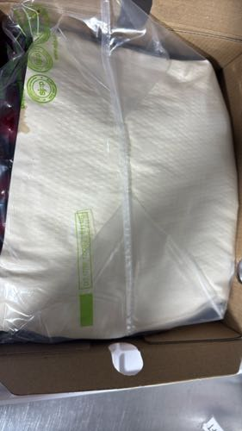 | 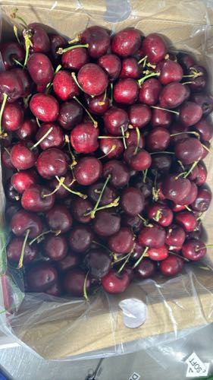 | 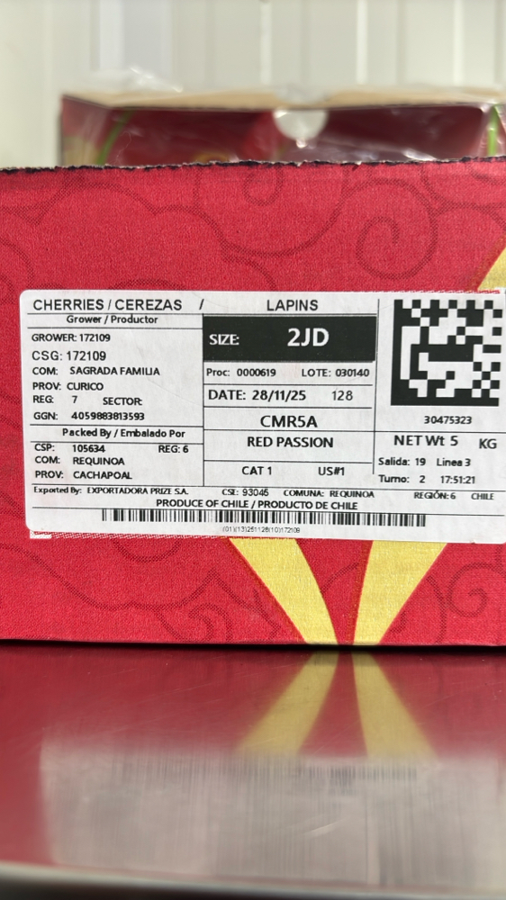

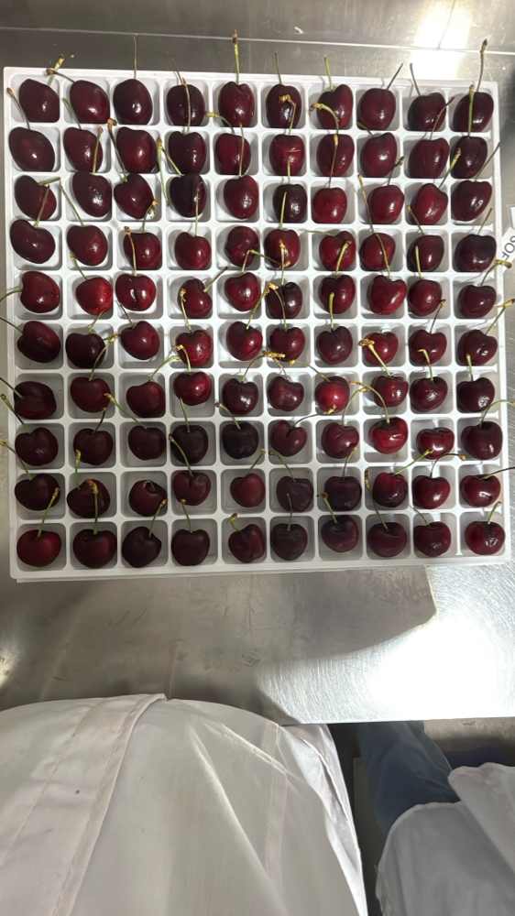 | 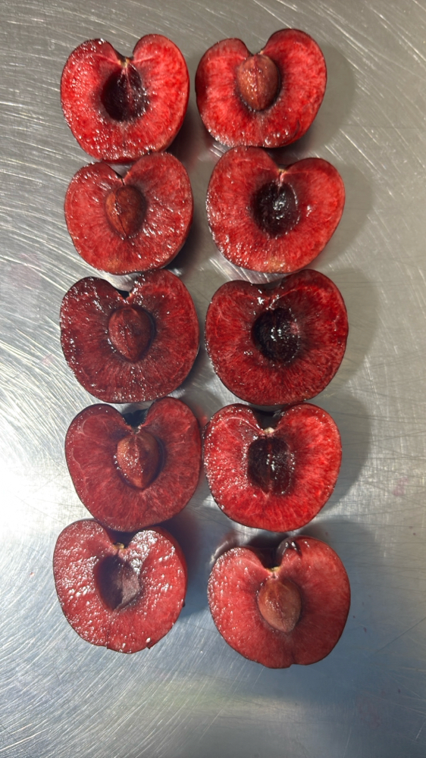 | 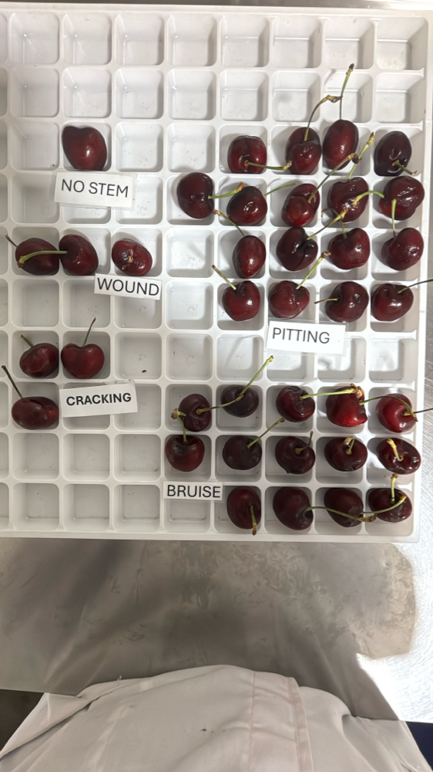 | 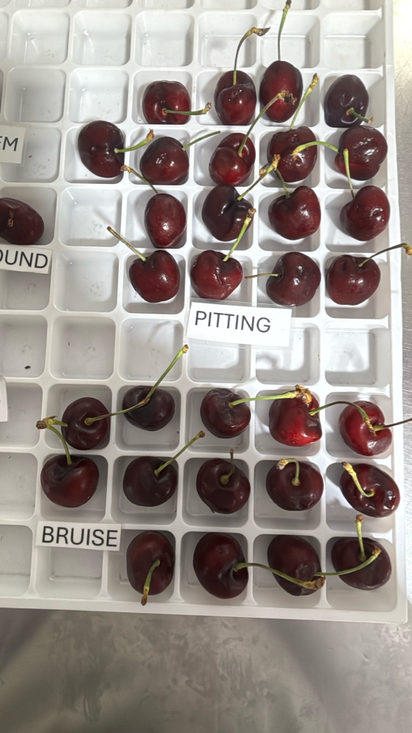

|  |  |  |  |  |  |  |  |  |  |  |  |
| --- | --- | --- | --- | --- | --- | --- | --- | --- | --- | --- | --- |
| Box Id | Soft | Wound | Bruise | Stain | Cracking | No Stem | Pitting | Decay | Avg Brix | Open | Firmness |
| 40976202 | 0 % | 0 % | 0 % | 0 % | 4 % | 4 % | 8 % | 0 % | 17.760000 | GOOD | GOOD |

Open

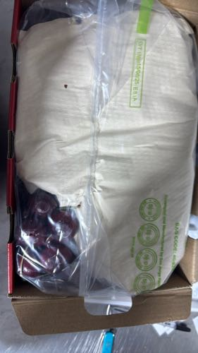 | 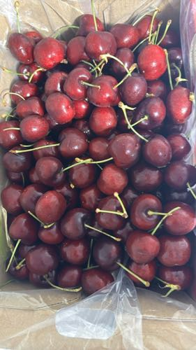 | 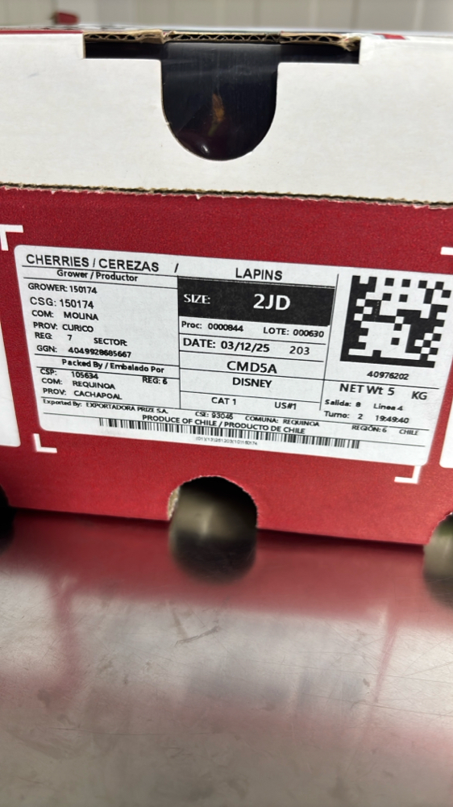

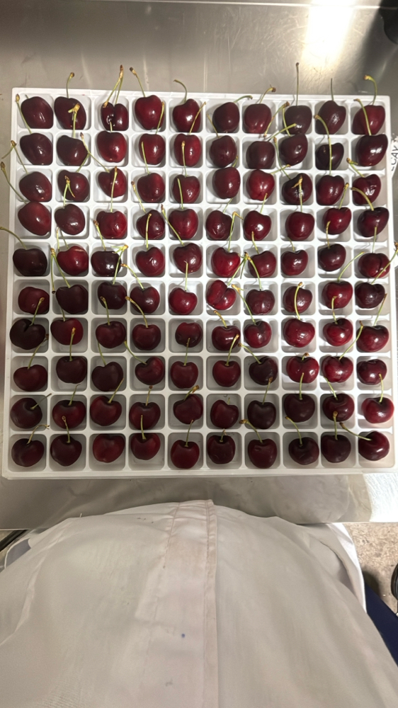 | 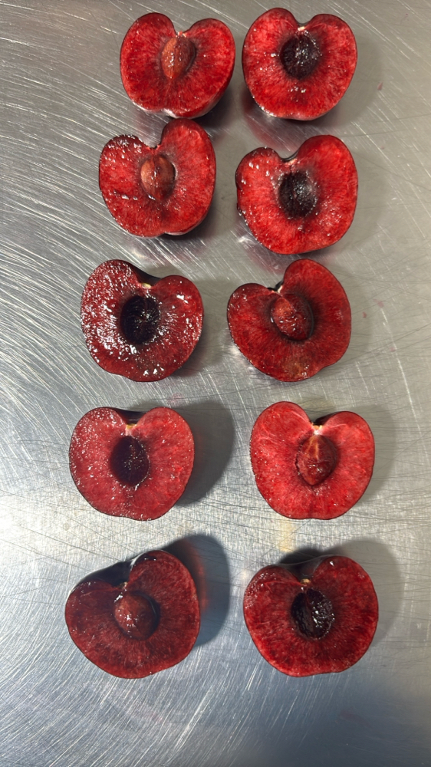 | 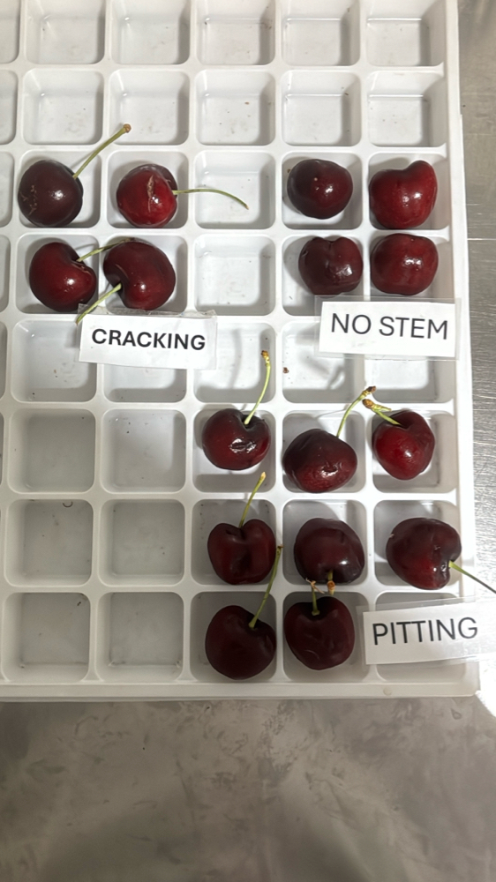 | 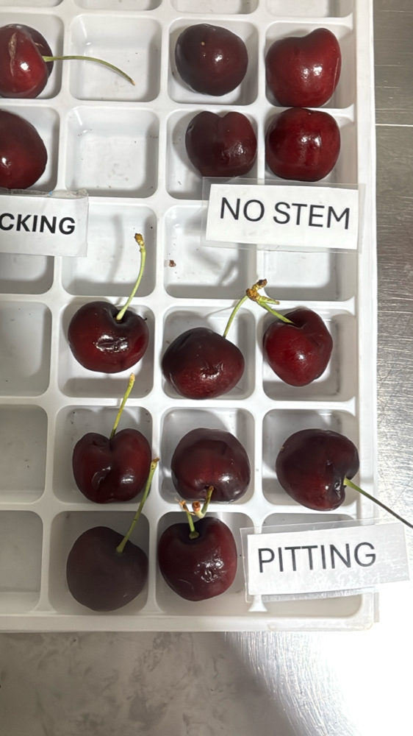

|  |  |  |  |  |  |  |  |  |  |  |  |
| --- | --- | --- | --- | --- | --- | --- | --- | --- | --- | --- | --- |
| Box Id | Soft | Wound | Bruise | Stain | Cracking | No Stem | Pitting | Decay | Avg Brix | Open | Firmness |
| 30828606 | 0 % | 3 % | 3 % | 0 % | 3 % | 10 % | 7 % | 0 % | 19.000000 | GOOD | GOOD |

Open

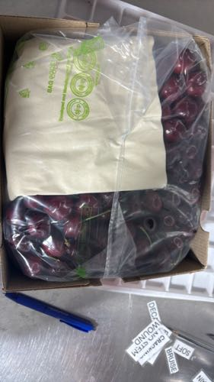 | 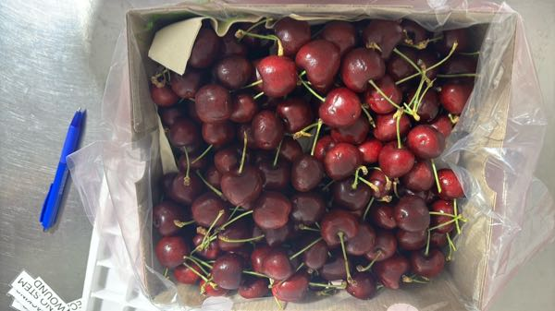 | 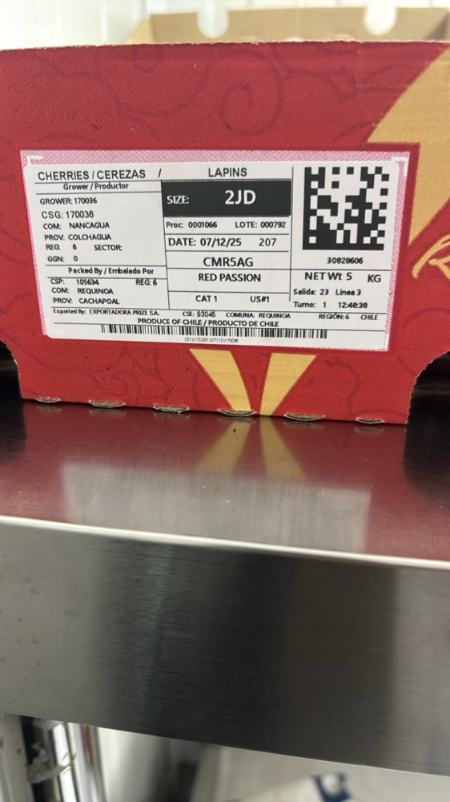

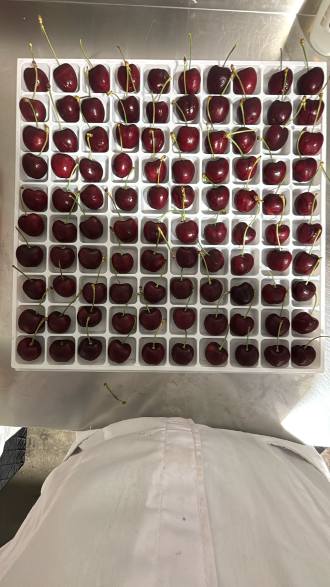 | 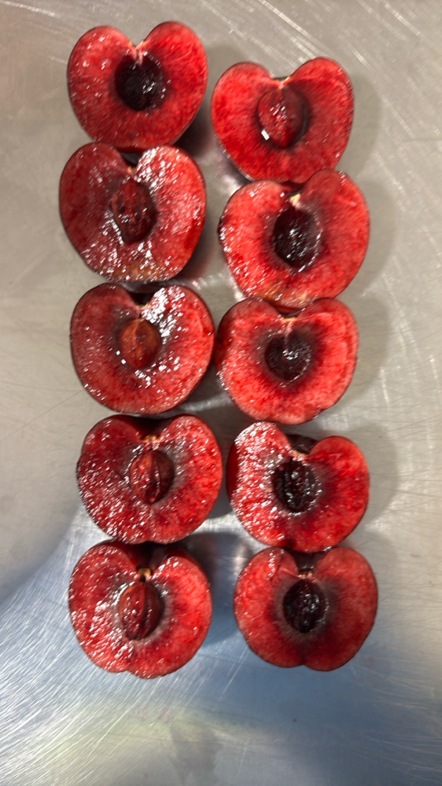 | 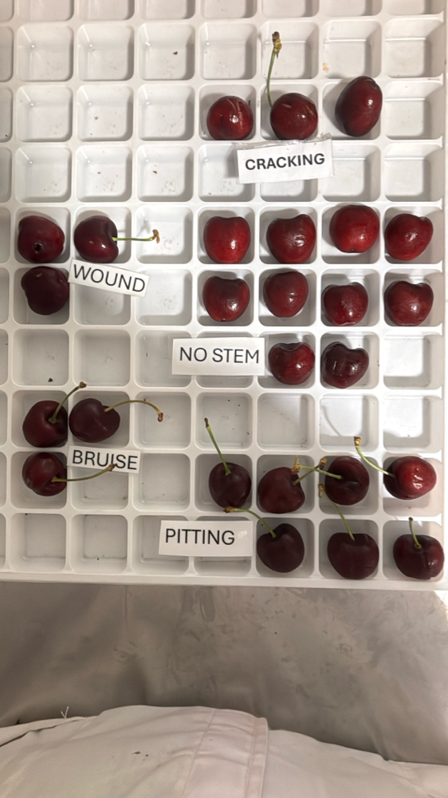 | 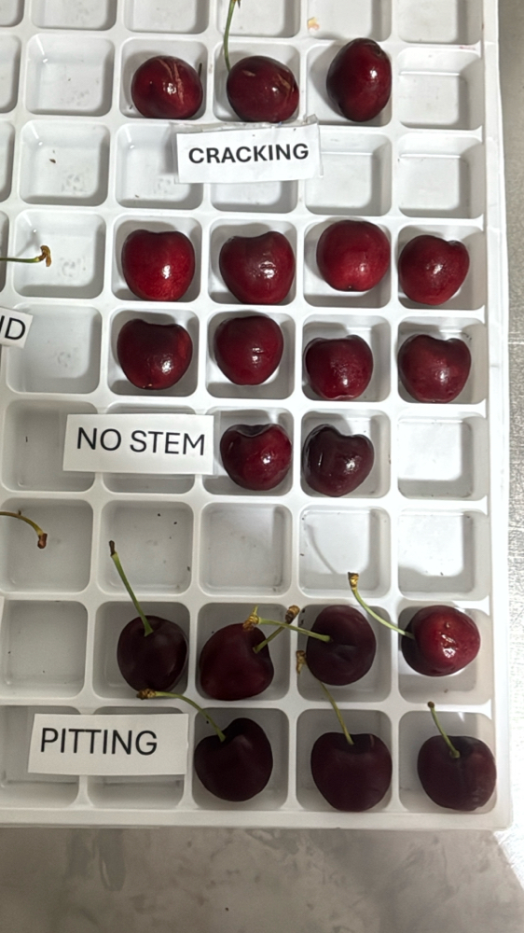

|  |  |  |  |  |  |  |  |  |  |  |  |
| --- | --- | --- | --- | --- | --- | --- | --- | --- | --- | --- | --- |
| Box Id | Soft | Wound | Bruise | Stain | Cracking | No Stem | Pitting | Decay | Avg Brix | Open | Firmness |
| 30583981 | 0 % | 6 % | 0 % | 0 % | 0 % | 4 % | 24 % | 0 % | 20.280000 | GOOD | GOOD |

Open

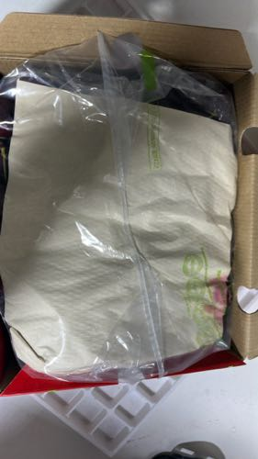 | 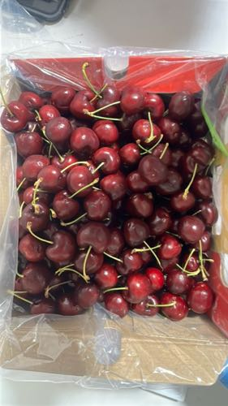 | 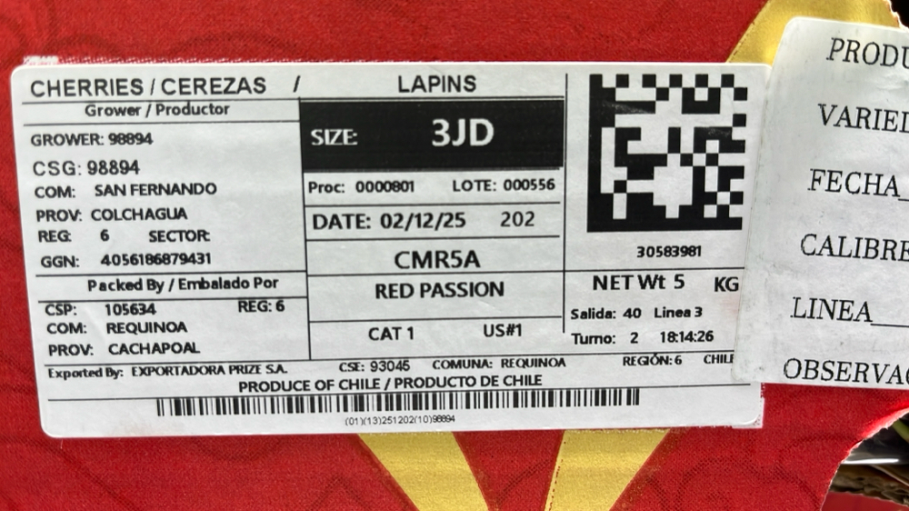

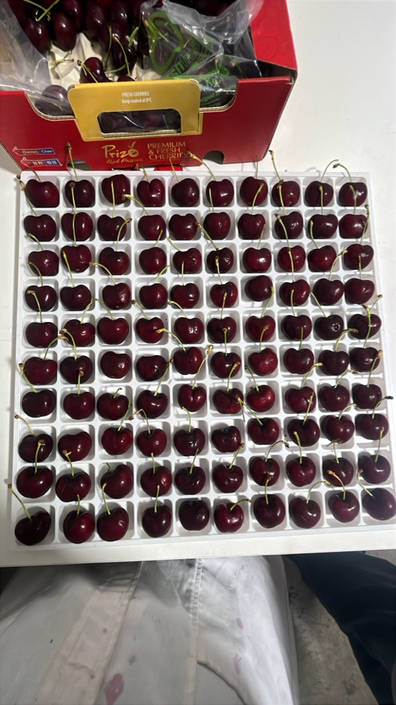 | 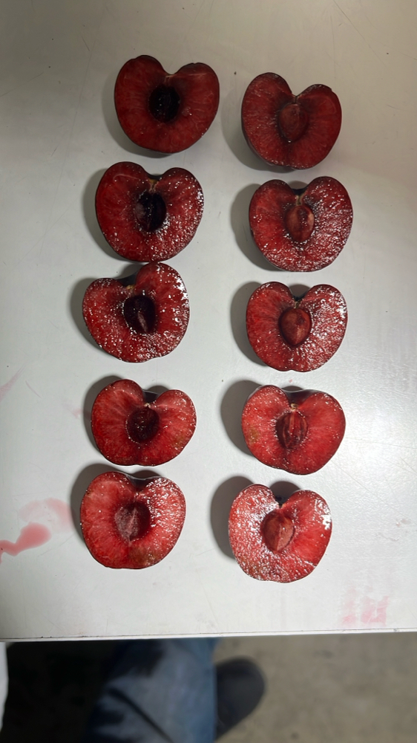 | 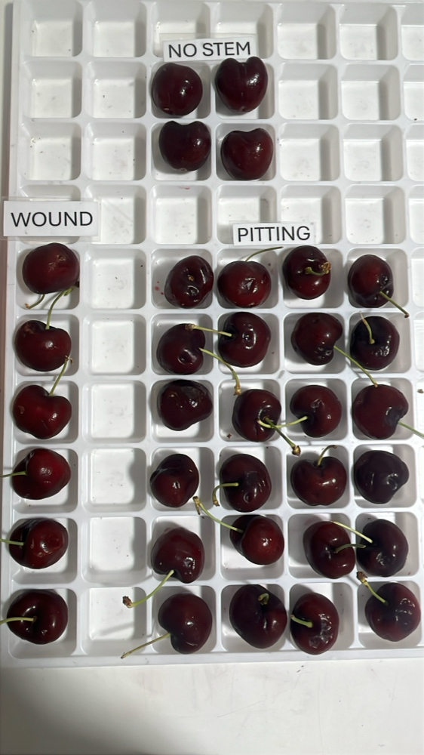 | 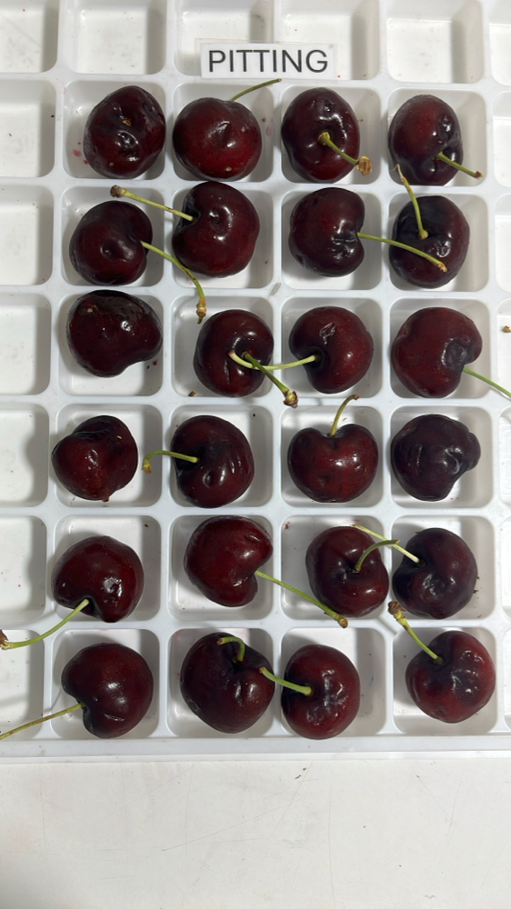

|  |  |  |  |  |  |  |  |  |  |  |  |
| --- | --- | --- | --- | --- | --- | --- | --- | --- | --- | --- | --- |
| Box Id | Soft | Wound | Bruise | Stain | Cracking | No Stem | Pitting | Decay | Avg Brix | Open | Firmness |
| 41111075 | 0 % | 5 % | 0 % | 0 % | 6 % | 11 % | 4 % | 0 % | 18.920000 | GOOD | GOOD |

Open

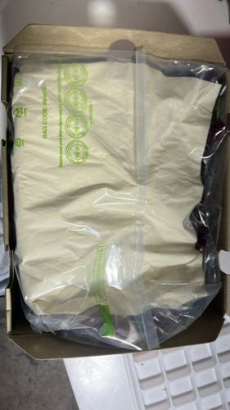 | 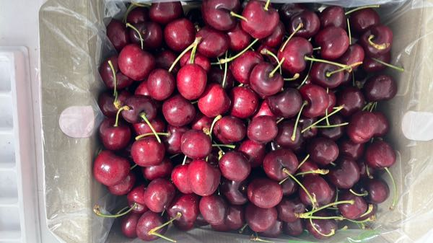 | 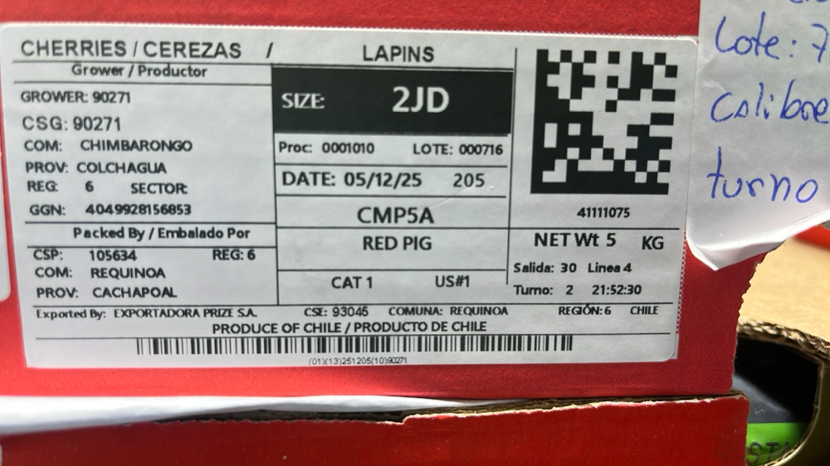

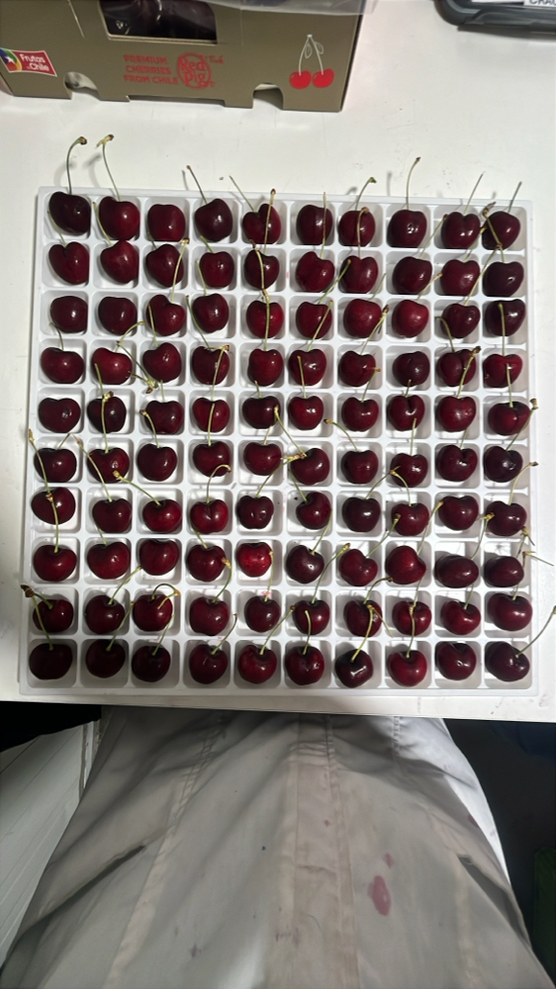 | 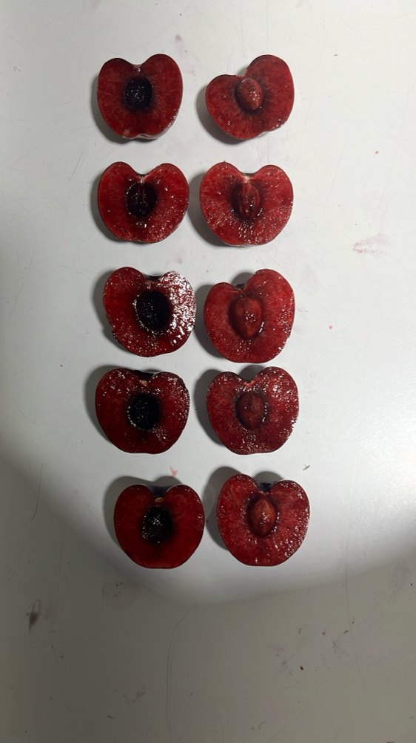 | 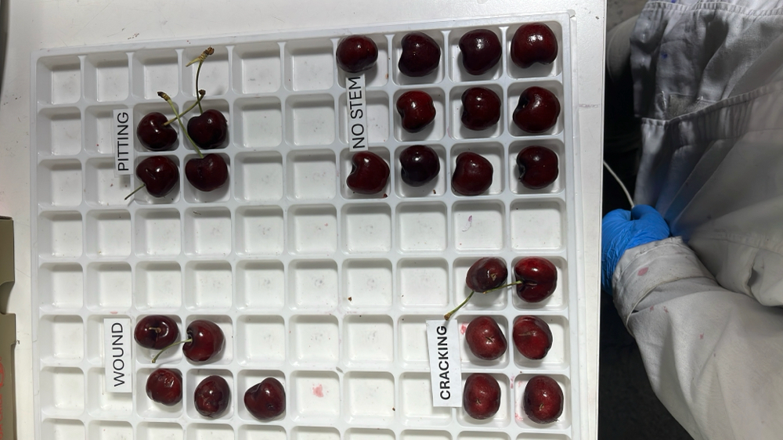 | 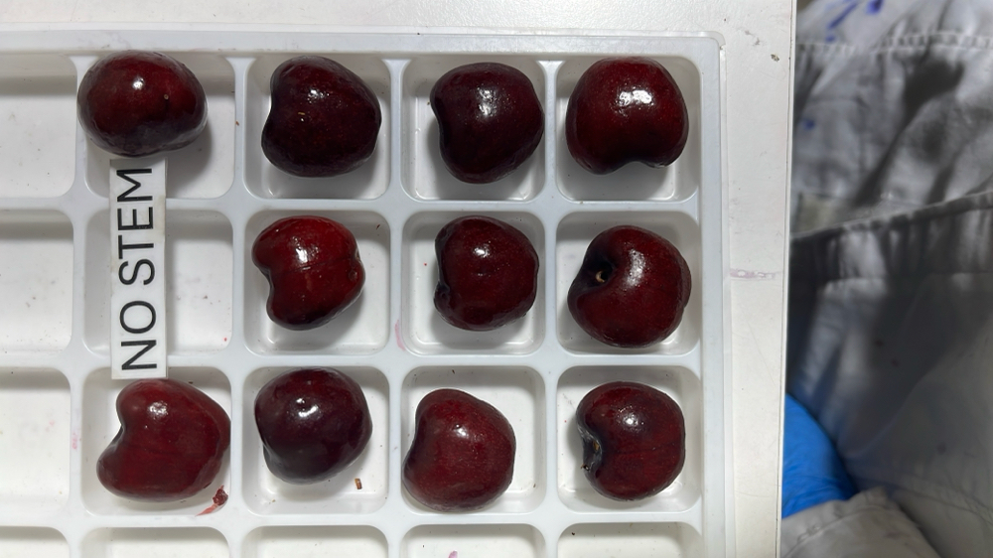

|  |  |  |  |  |  |  |  |  |  |  |  |
| --- | --- | --- | --- | --- | --- | --- | --- | --- | --- | --- | --- |
| Box Id | Soft | Wound | Bruise | Stain | Cracking | No Stem | Pitting | Decay | Avg Brix | Open | Firmness |
| 30766458 | 1 % | 4 % | 0 % | 0 % | 1 % | 6 % | 18 % | 0 % | 17.400000 | GOOD |  |

Open

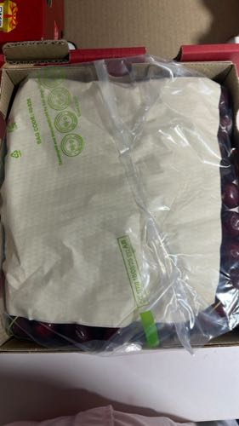 | 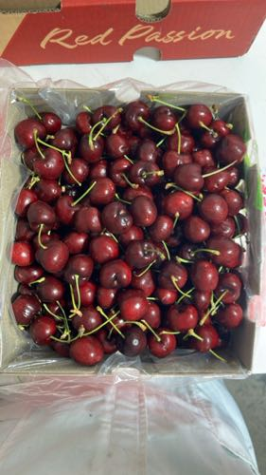 | 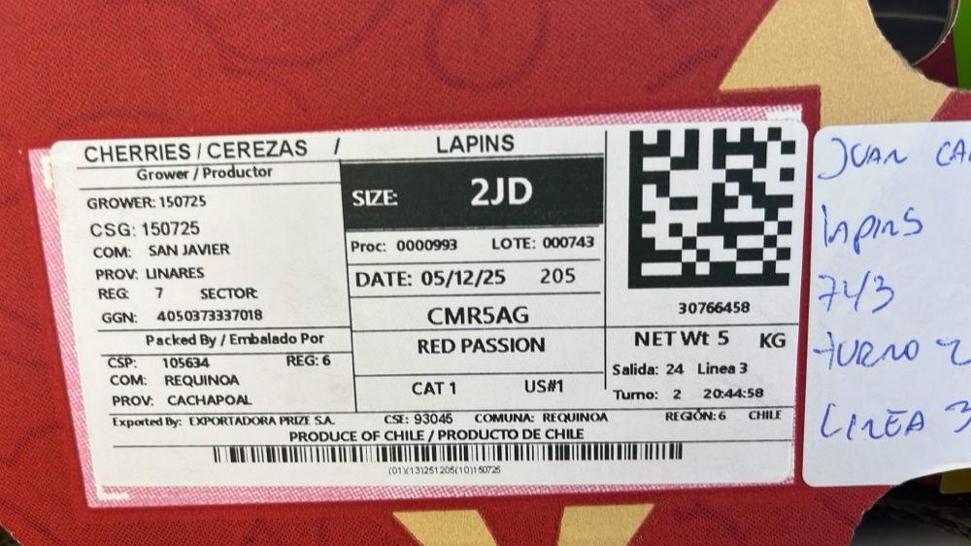

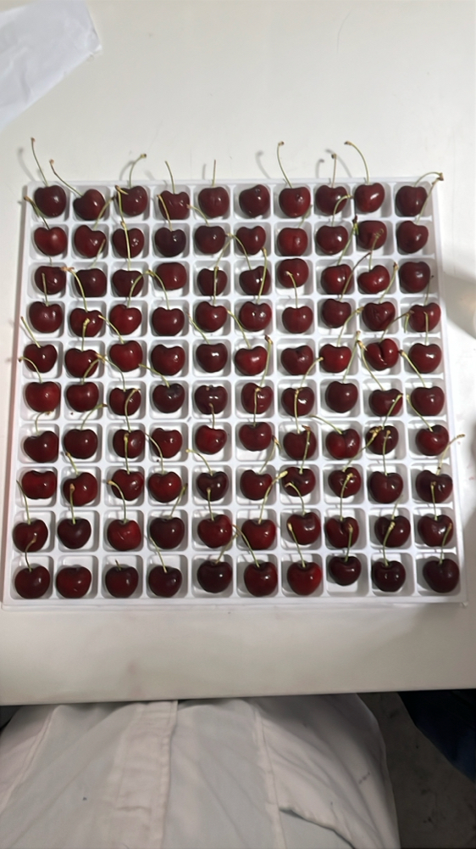 | 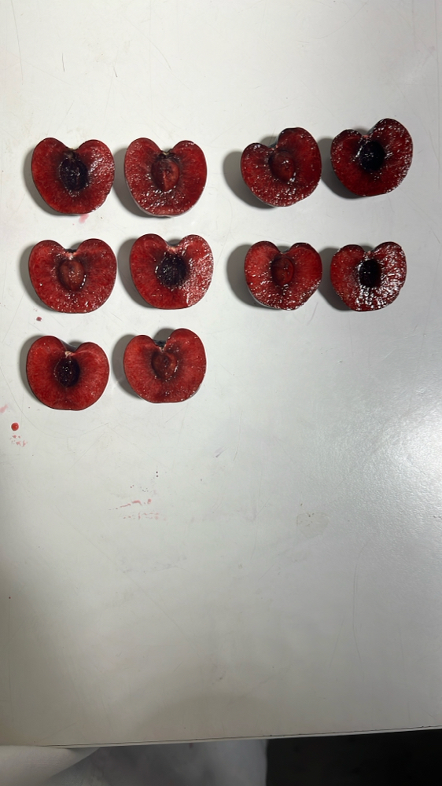 | 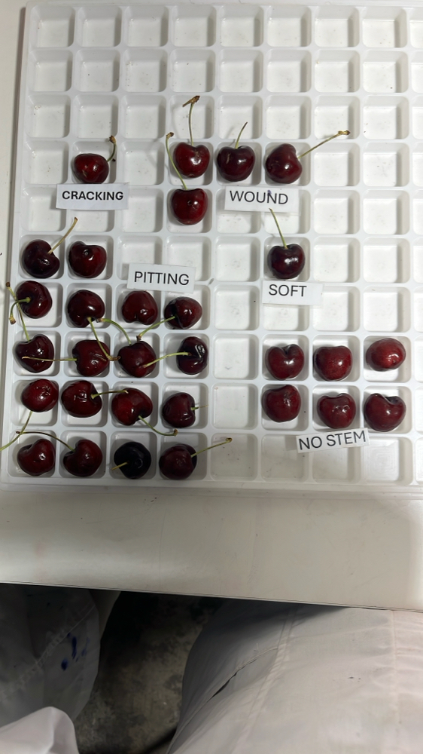 | 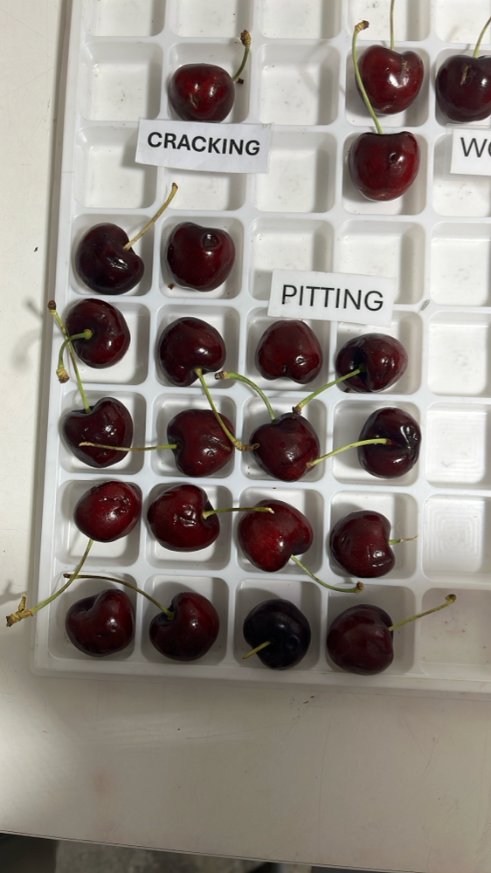

|  |  |  |  |  |  |  |  |  |  |  |  |
| --- | --- | --- | --- | --- | --- | --- | --- | --- | --- | --- | --- |
| Box Id | Soft | Wound | Bruise | Stain | Cracking | No Stem | Pitting | Decay | Avg Brix | Open | Firmness |
| 40836531 | 9 % | 1 % | 5 % | 0 % | 4 % | 3 % | 27 % | 1 % | 19.400000 | GOOD | GOOD |

Open

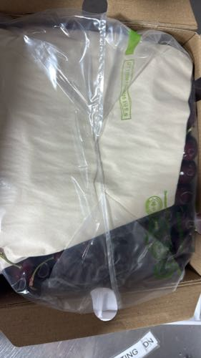 | 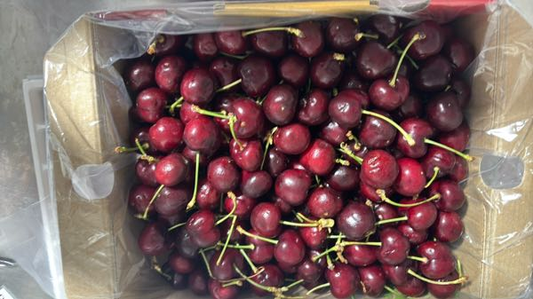 | 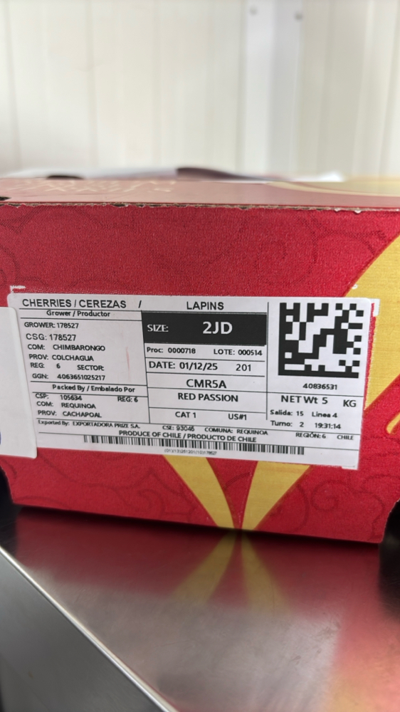

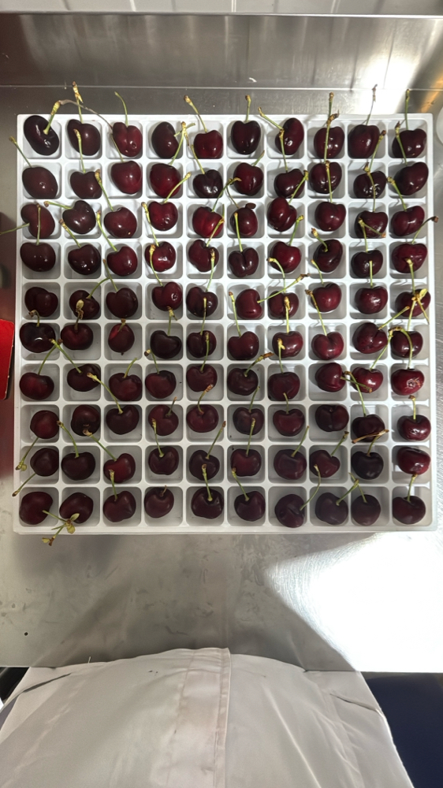 | 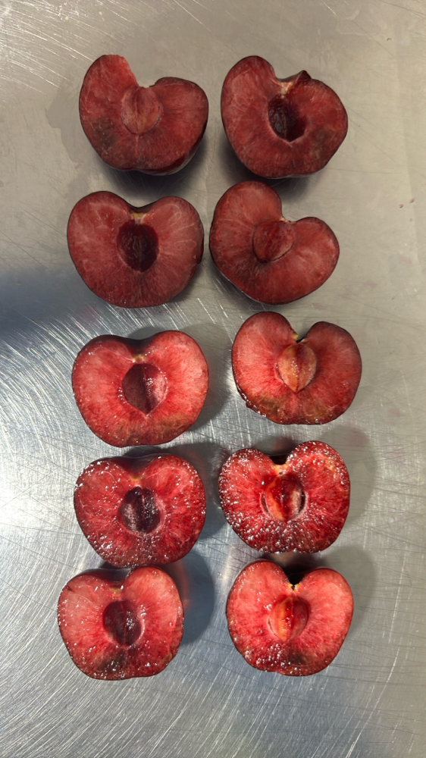 | 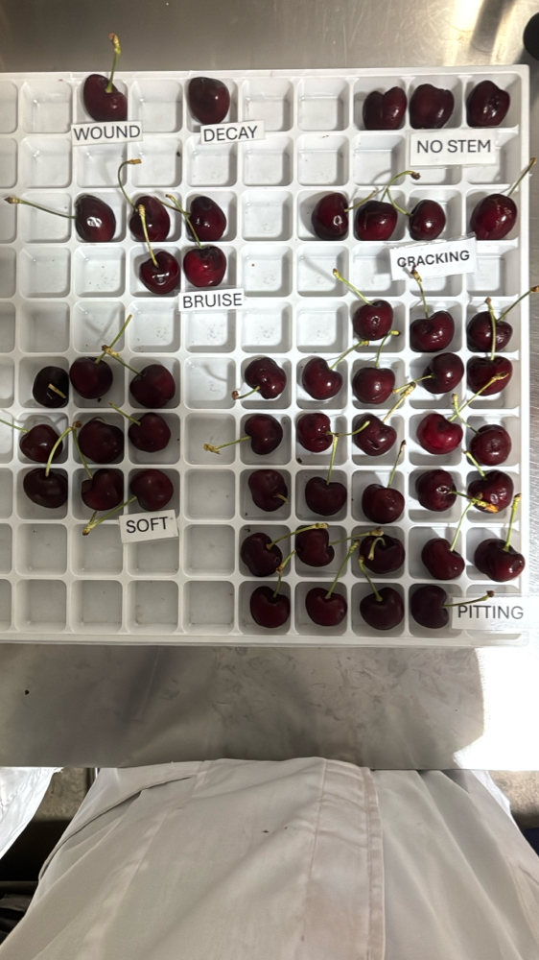 | 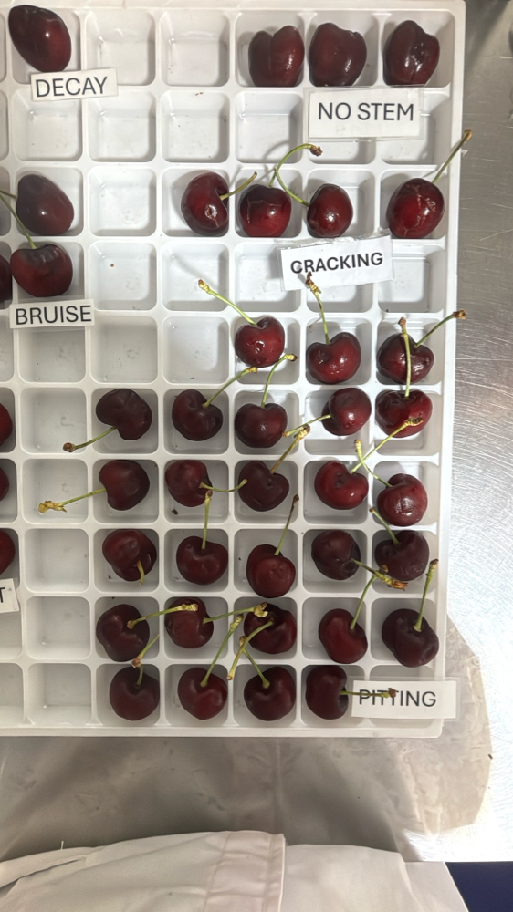

|  |  |  |  |  |  |  |  |  |  |  |  |
| --- | --- | --- | --- | --- | --- | --- | --- | --- | --- | --- | --- |
| Box Id | Soft | Wound | Bruise | Stain | Cracking | No Stem | Pitting | Decay | Avg Brix | Open | Firmness |
| 30613250 | 0 % | 1 % | 0 % | 0 % | 1 % | 10 % | 9 % | 0 % | 19.880000 | GOOD | GOOD |

Open

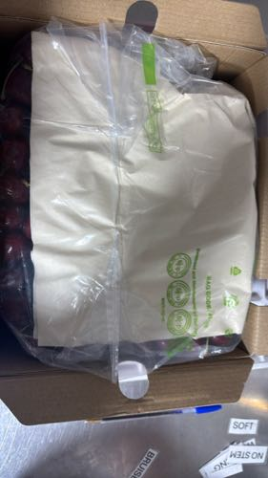 | 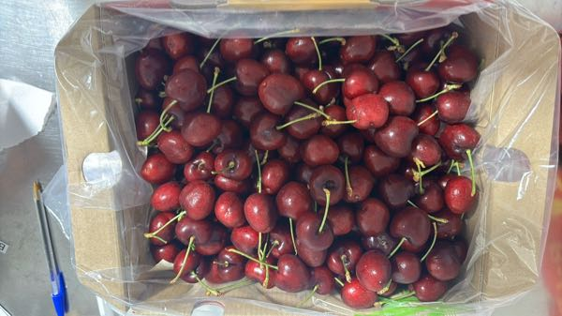 | 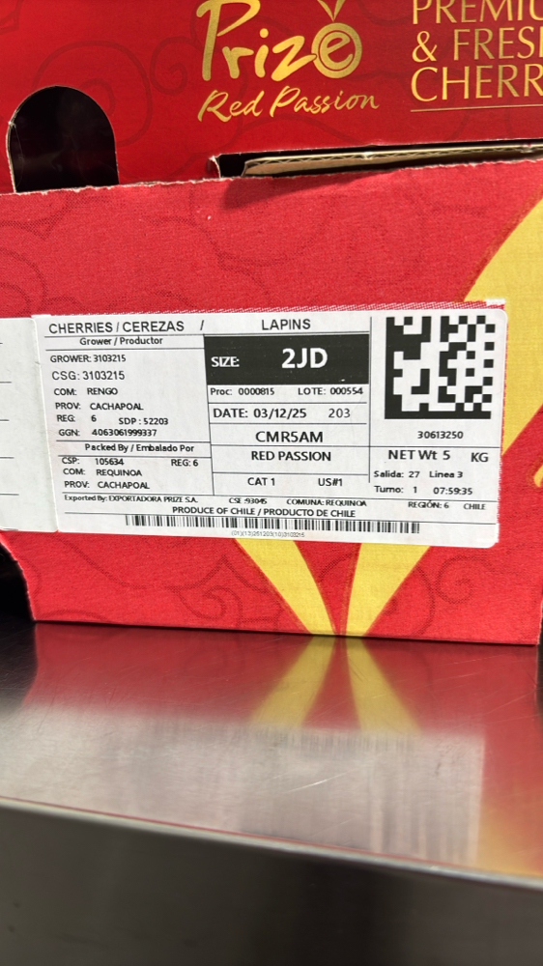

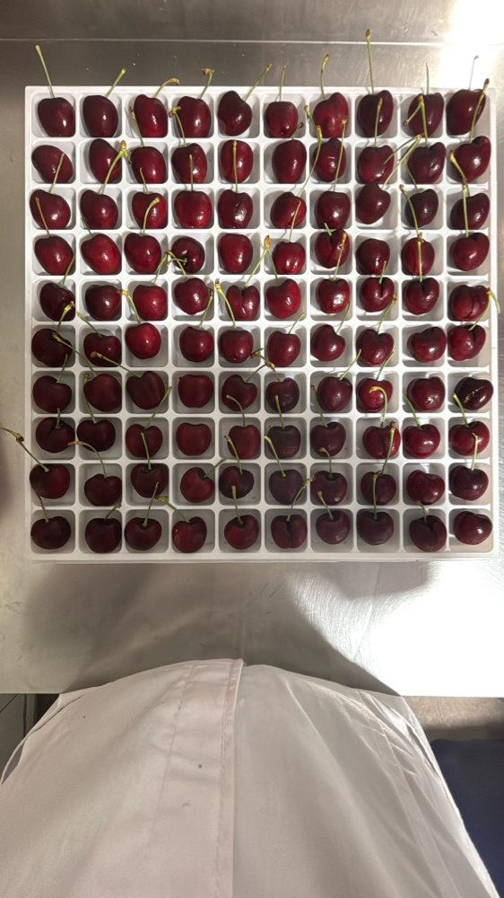 | 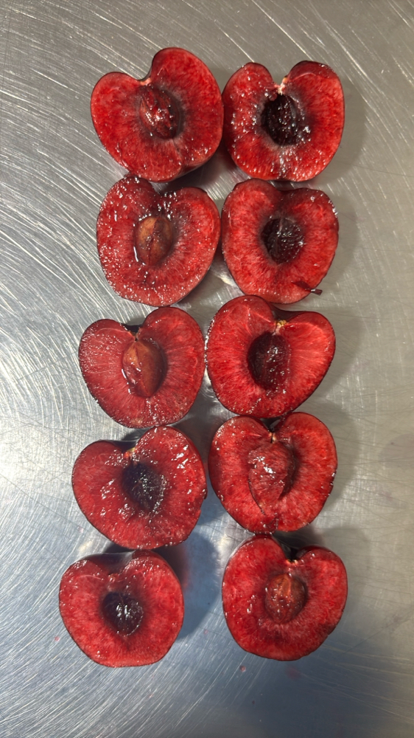 | 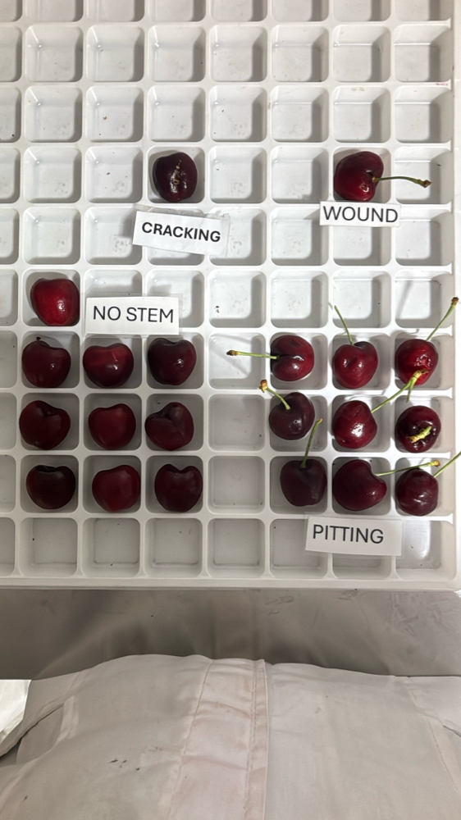 | 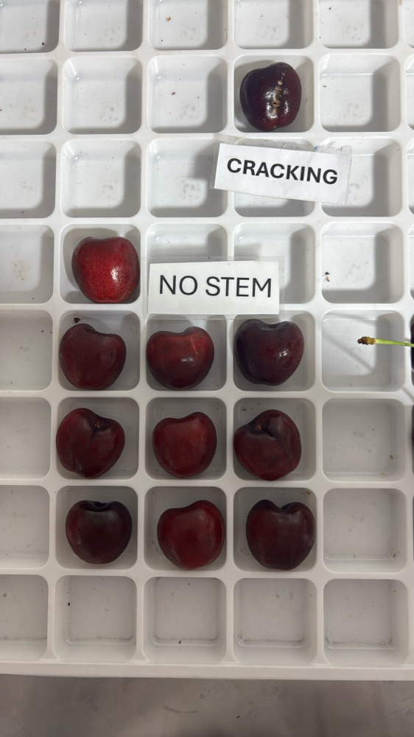

|  |  |  |  |  |  |  |  |  |  |  |  |
| --- | --- | --- | --- | --- | --- | --- | --- | --- | --- | --- | --- |
| Box Id | Soft | Wound | Bruise | Stain | Cracking | No Stem | Pitting | Decay | Avg Brix | Open | Firmness |
| 41138208 | 1 % | 0 % | 7 % | 0 % | 2 % | 9 % | 19 % | 3 % | 21.040000 | GOOD | GOOD |

Open

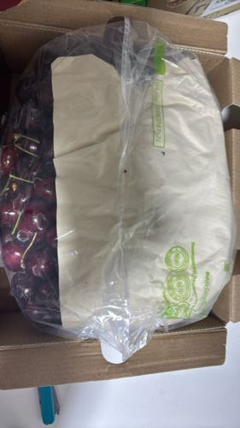 | 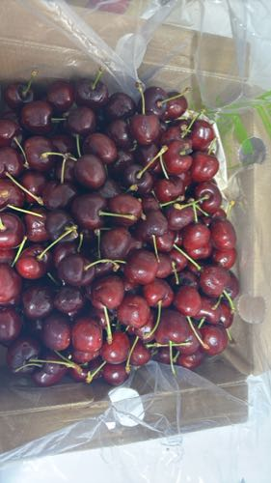 | 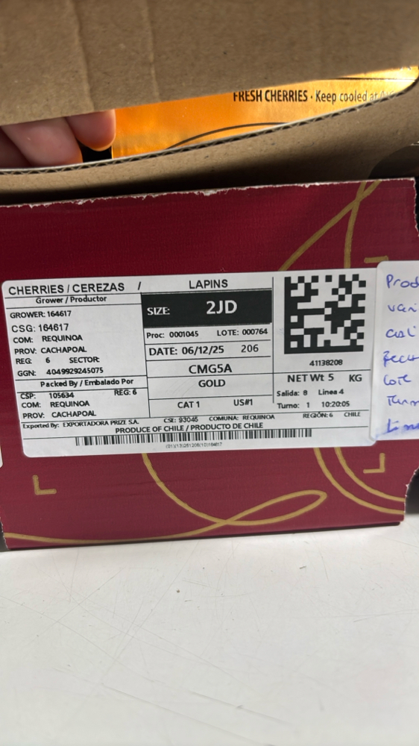

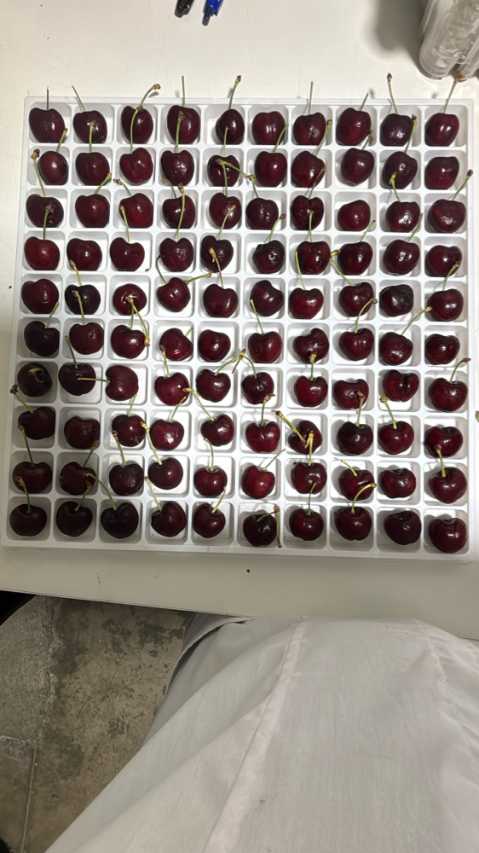 | 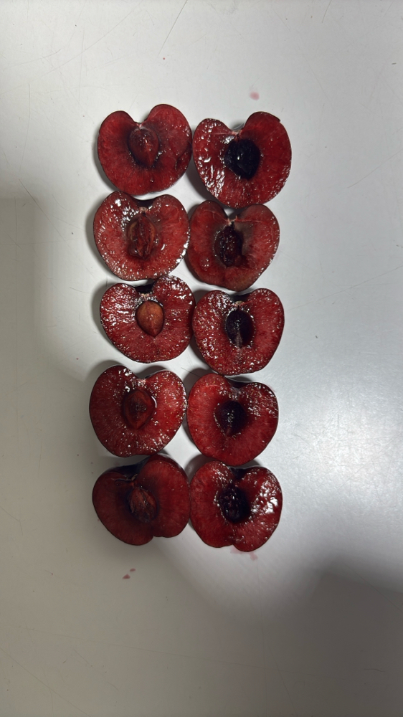 | 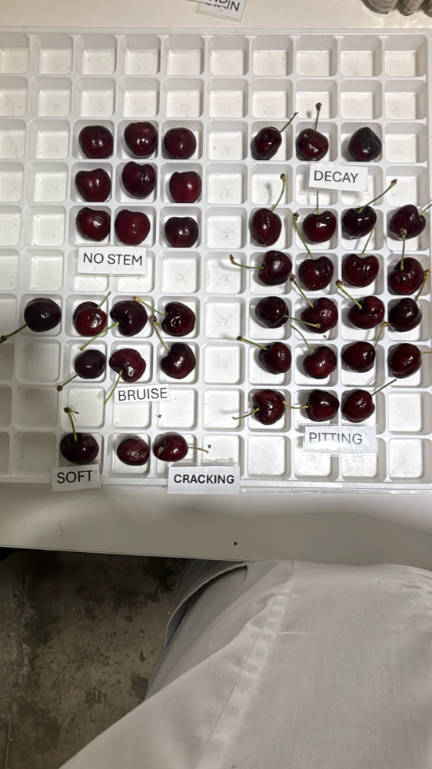 | 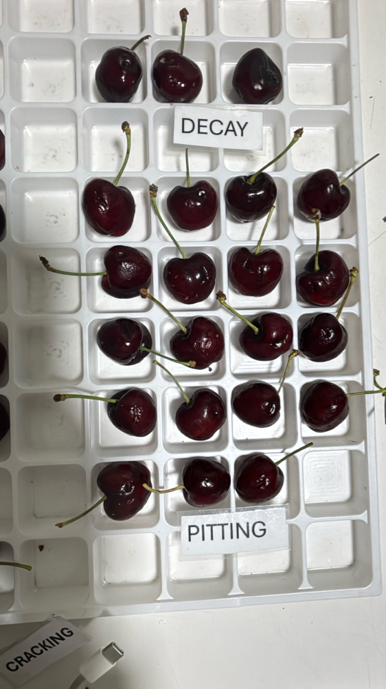

|  |  |  |  |  |  |  |  |  |  |  |  |
| --- | --- | --- | --- | --- | --- | --- | --- | --- | --- | --- | --- |
| Box Id | Soft | Wound | Bruise | Stain | Cracking | No Stem | Pitting | Decay | Avg Brix | Open | Firmness |
| 30615016 | 0 % | 3 % | 0 % | 0 % | 1 % | 11 % | 12 % | 0 % | 17.920000 | GOOD | GOOD |

Open

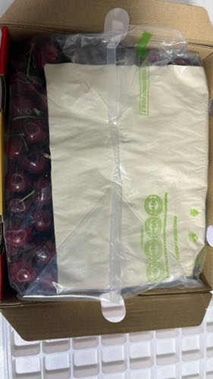 | 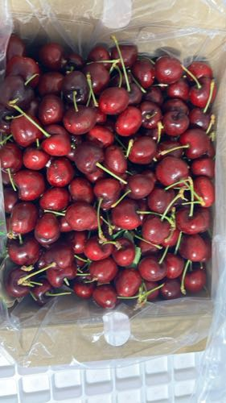 | 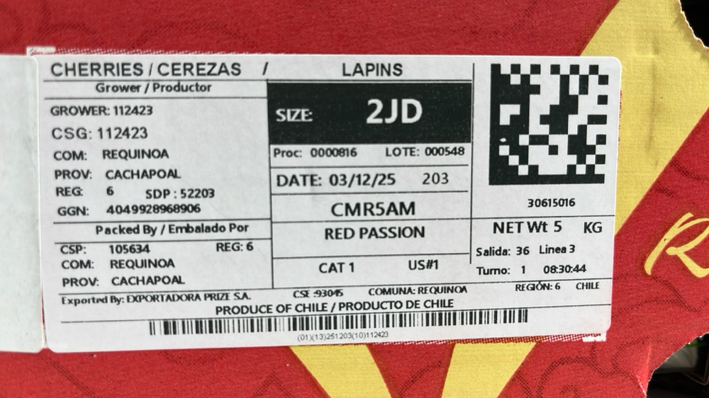

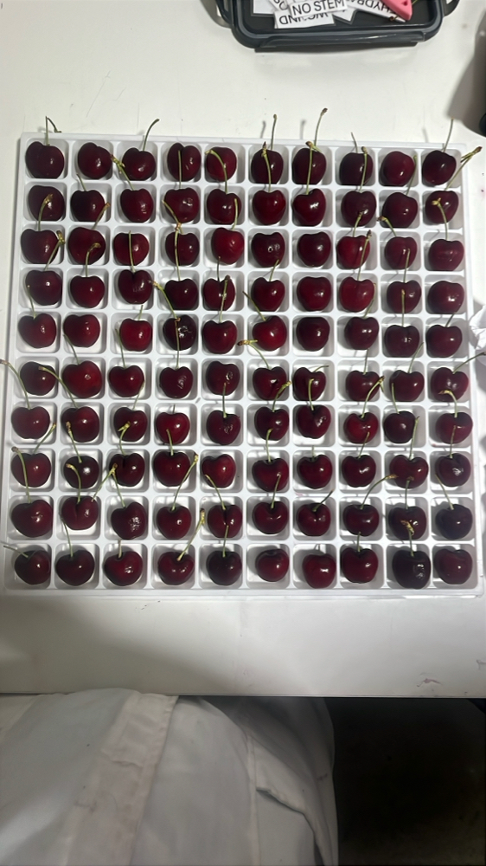 | 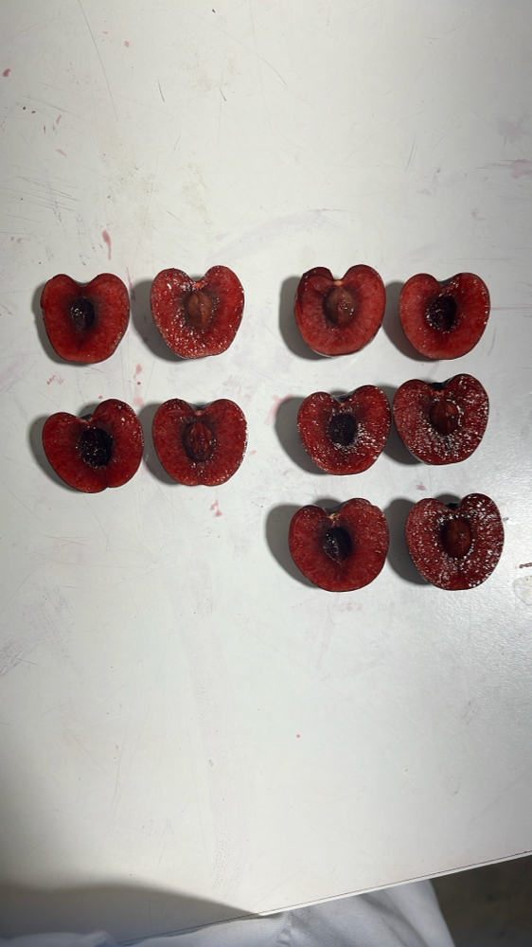 | 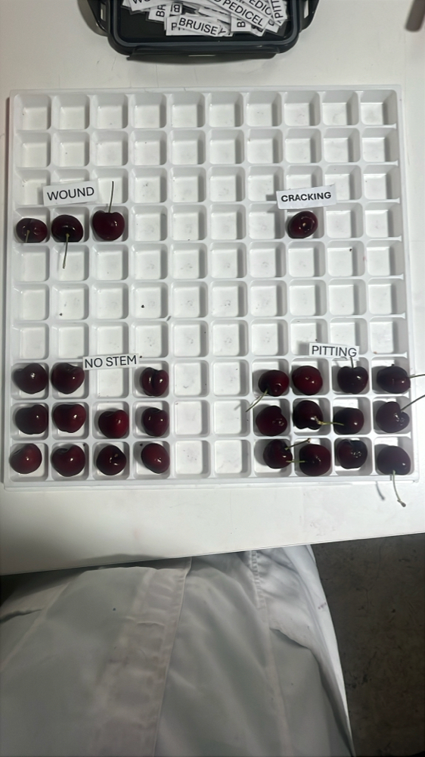 | 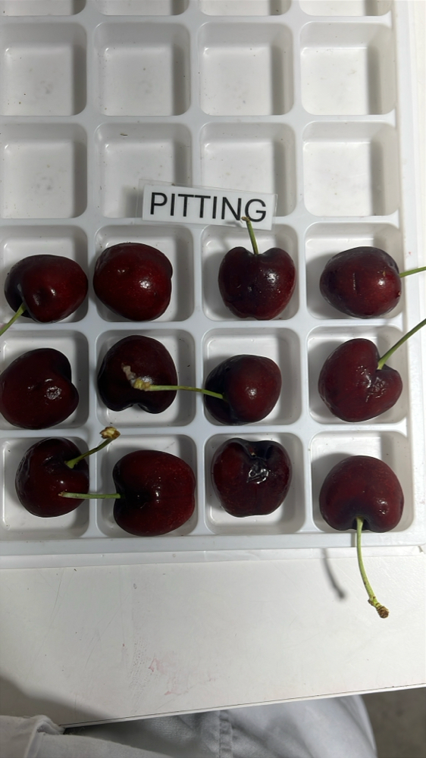

|  |  |  |  |  |  |  |  |  |  |  |  |
| --- | --- | --- | --- | --- | --- | --- | --- | --- | --- | --- | --- |
| Box Id | Soft | Wound | Bruise | Stain | Cracking | No Stem | Pitting | Decay | Avg Brix | Open | Firmness |
| 40976573 | 0 % | 0 % | 1 % | 0 % | 3 % | 1 % | 12 % | 0 % | 16.080000 | GOOD | GOOD |

Open

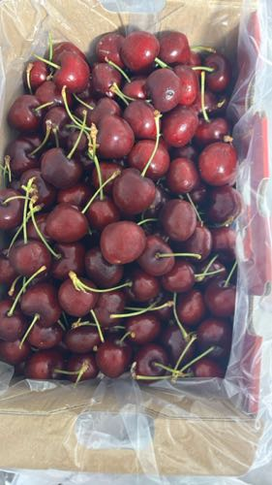 | 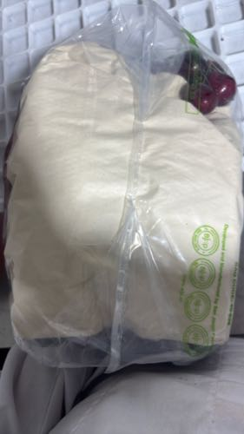 | 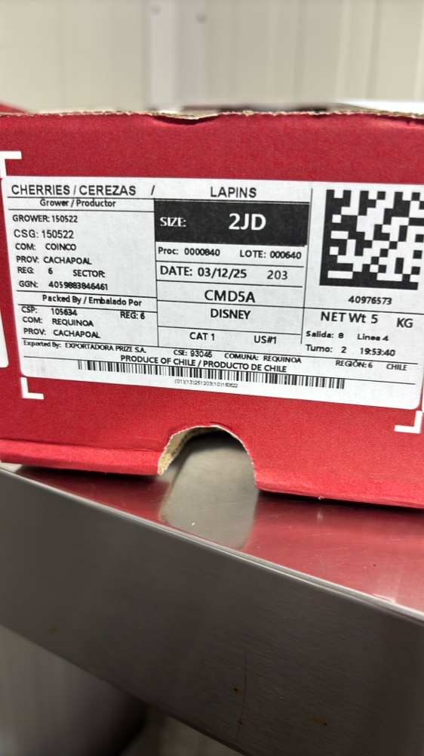

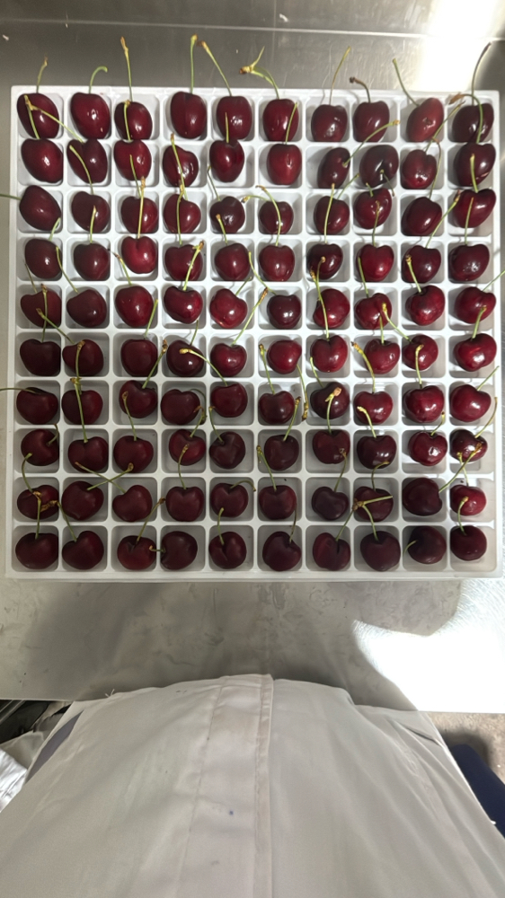 | 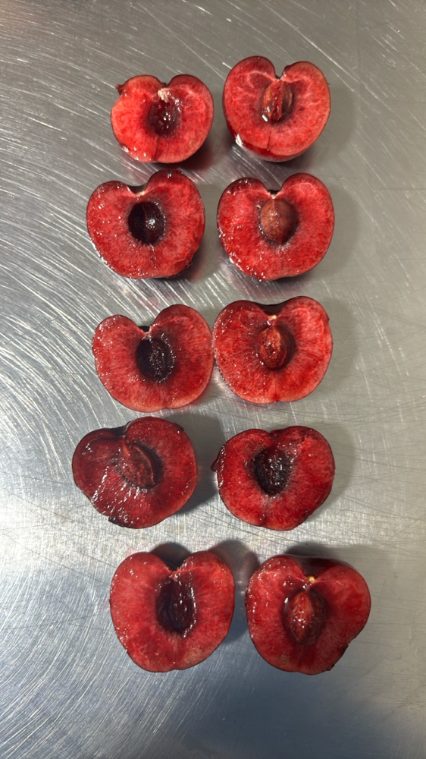 | 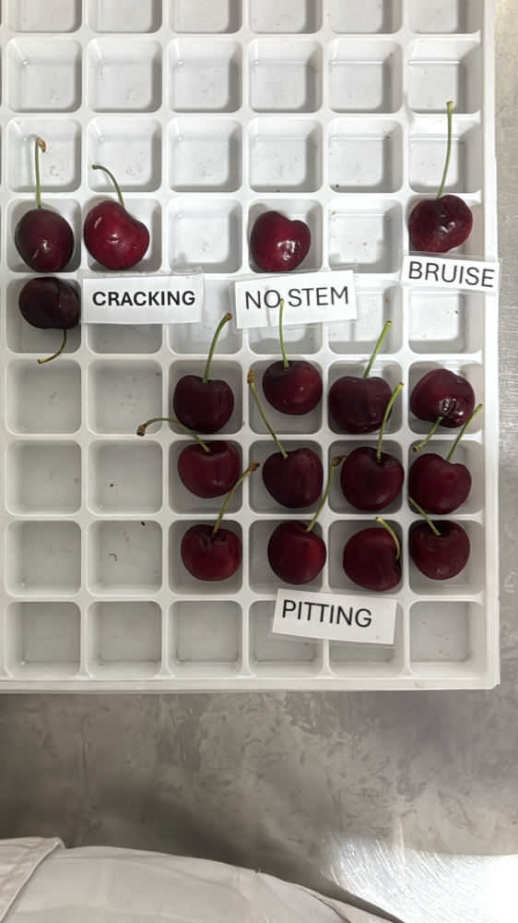 |

|  |  |  |  |  |  |  |  |  |  |  |  |
| --- | --- | --- | --- | --- | --- | --- | --- | --- | --- | --- | --- |
| Box Id | Soft | Wound | Bruise | Stain | Cracking | No Stem | Pitting | Decay | Avg Brix | Open | Firmness |
| 40842263 | 0 % | 0 % | 0 % | 0 % | 6 % | 5 % | 13 % | 0 % | 17.520000 | GOOD | GOOD |

Open

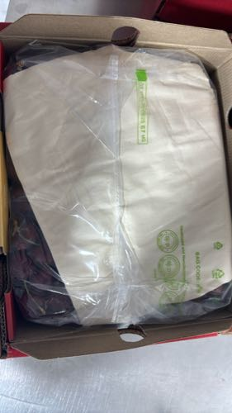 | 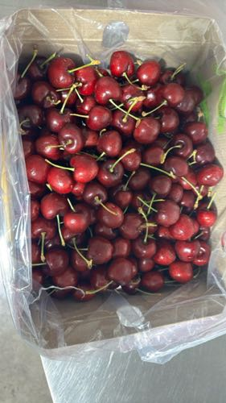 | 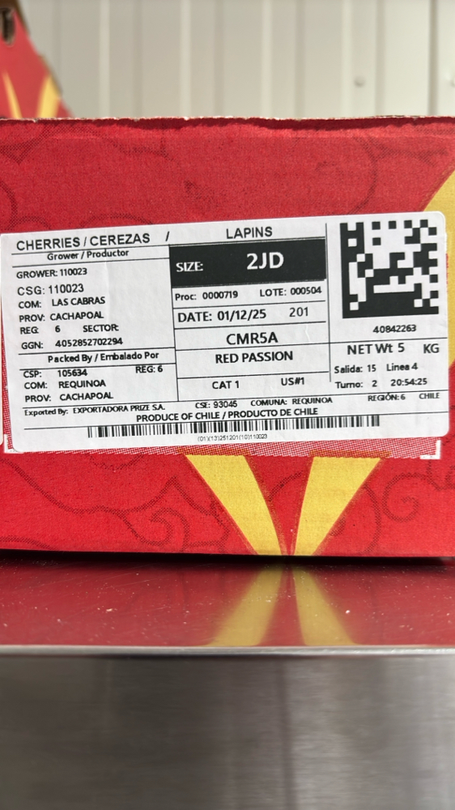

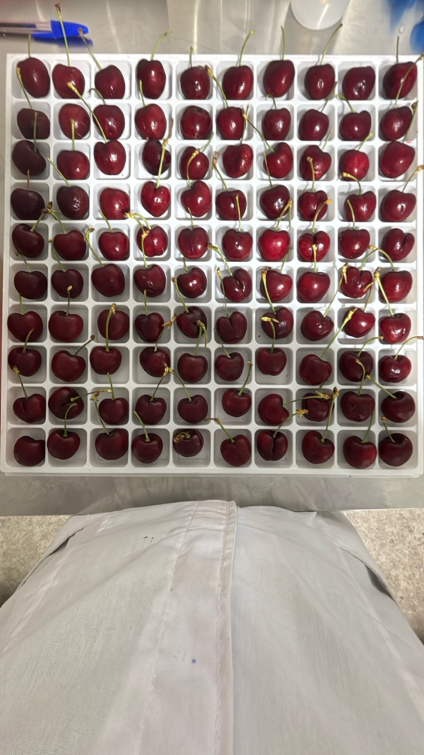 | 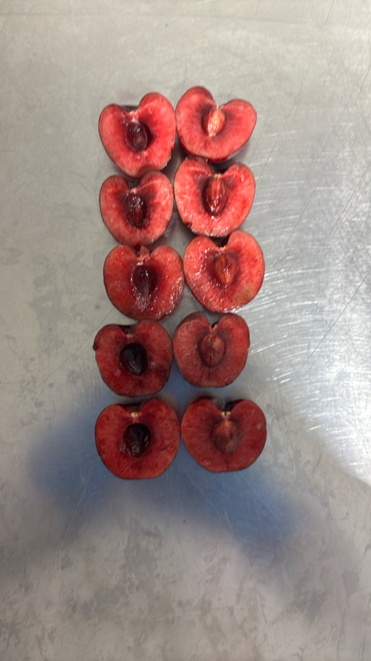 | 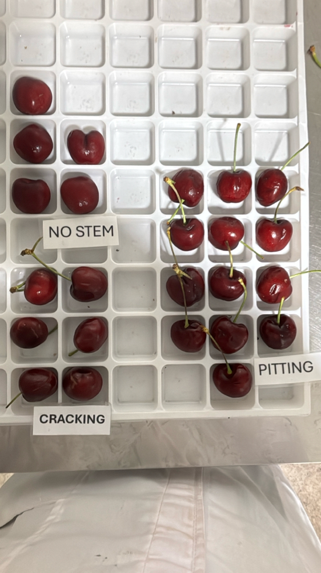 |

|  |  |  |  |  |  |  |  |  |  |  |  |
| --- | --- | --- | --- | --- | --- | --- | --- | --- | --- | --- | --- |
| Box Id | Soft | Wound | Bruise | Stain | Cracking | No Stem | Pitting | Decay | Avg Brix | Open | Firmness |
| 41088373 | 0 % | 0 % | 9 % | 0 % | 1 % | 5 % | 24 % | 0 % | 17.280000 | GOOD | GOOD |

Open

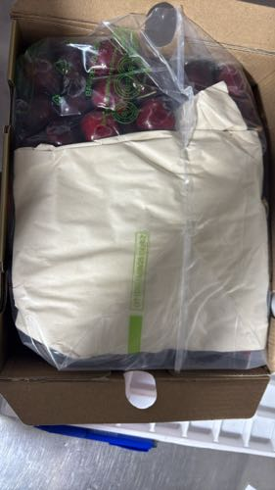 | 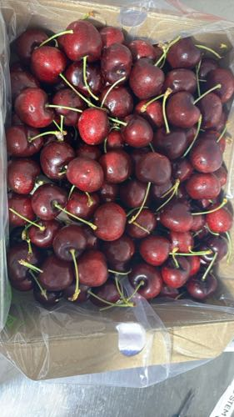 | 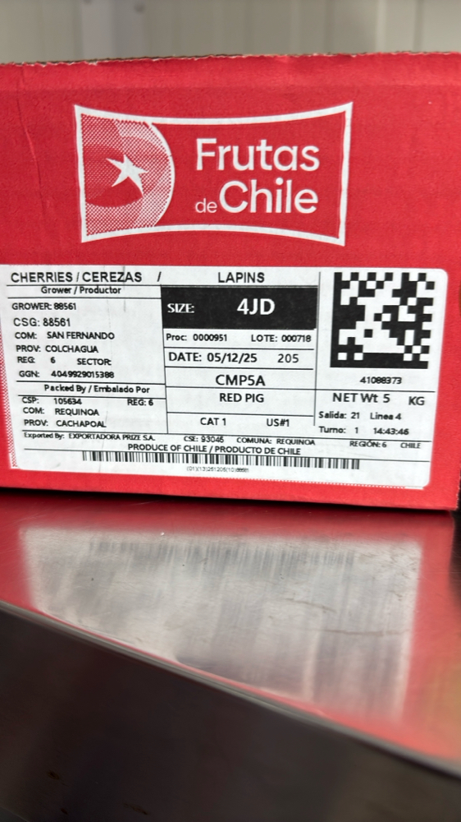

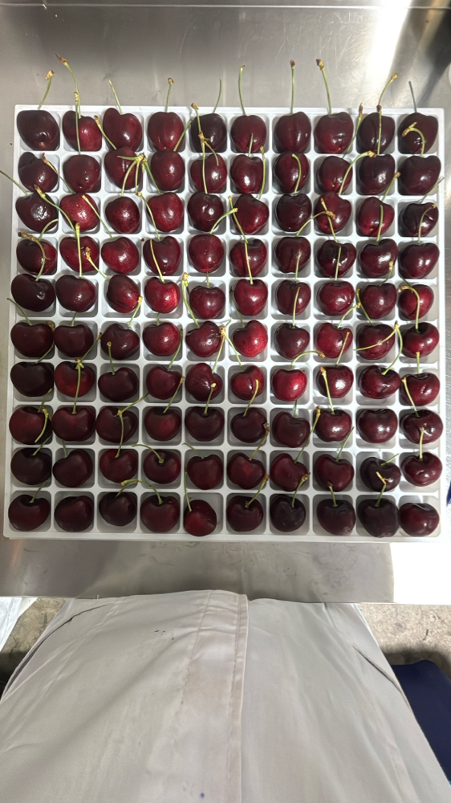 | 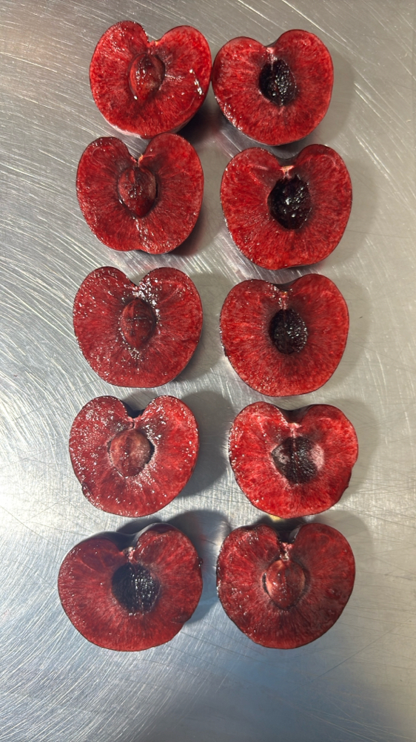 | 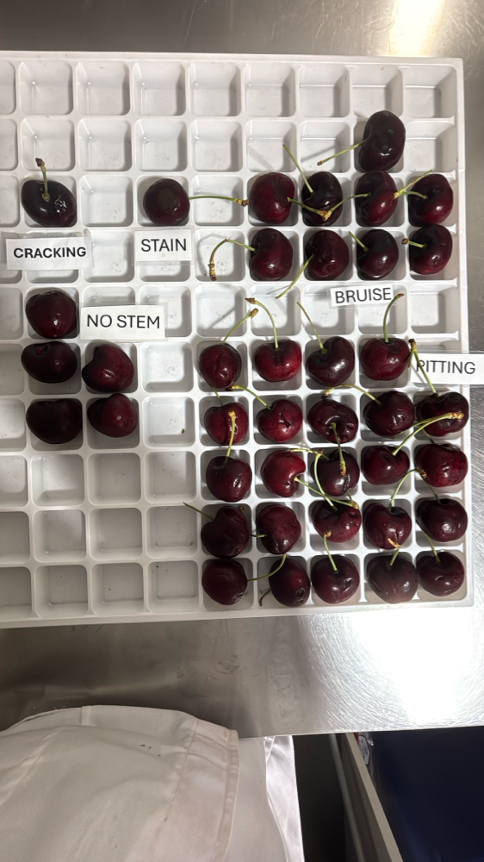 | 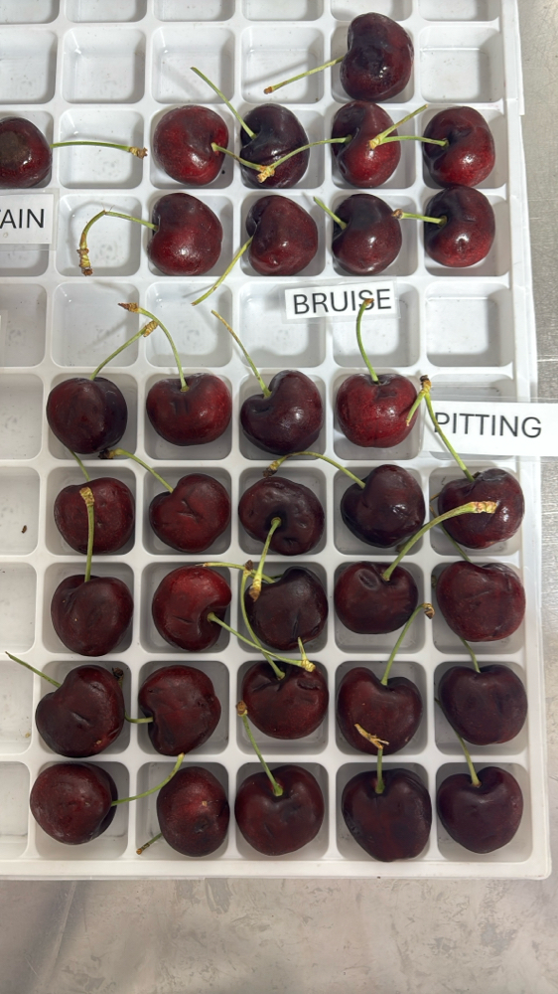

|  |  |  |  |  |  |  |  |  |  |  |  |
| --- | --- | --- | --- | --- | --- | --- | --- | --- | --- | --- | --- |
| Box Id | Soft | Wound | Bruise | Stain | Cracking | No Stem | Pitting | Decay | Avg Brix | Open | Firmness |
| 41013500 | 0 % | 0 % | 9 % | 0 % | 1 % | 19 % | 17 % | 0 % | 17.080000 | FAIR | GOOD |

Open

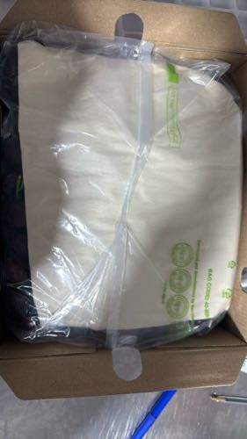 | 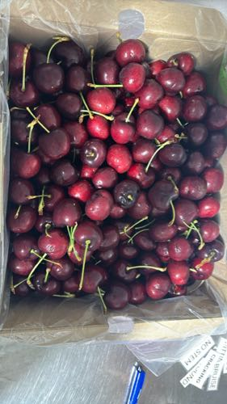 | 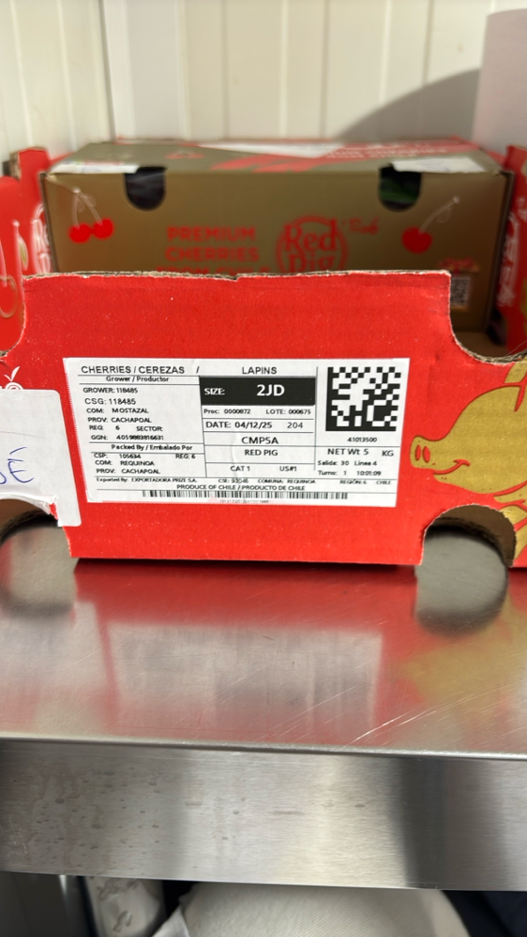

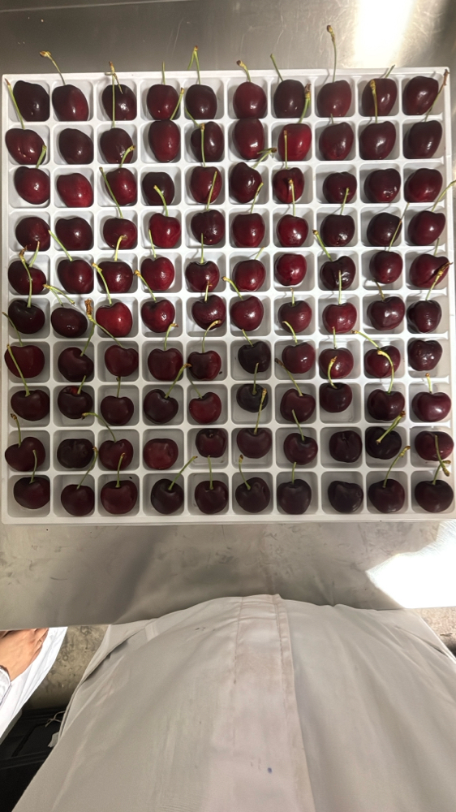 | 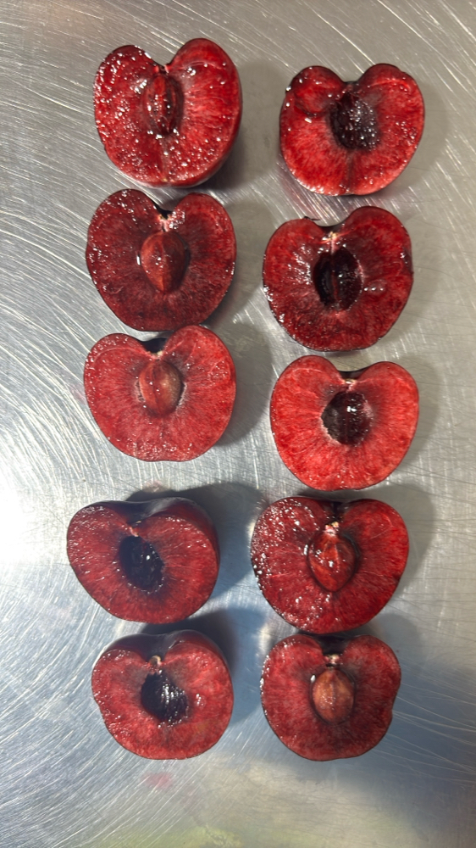 | 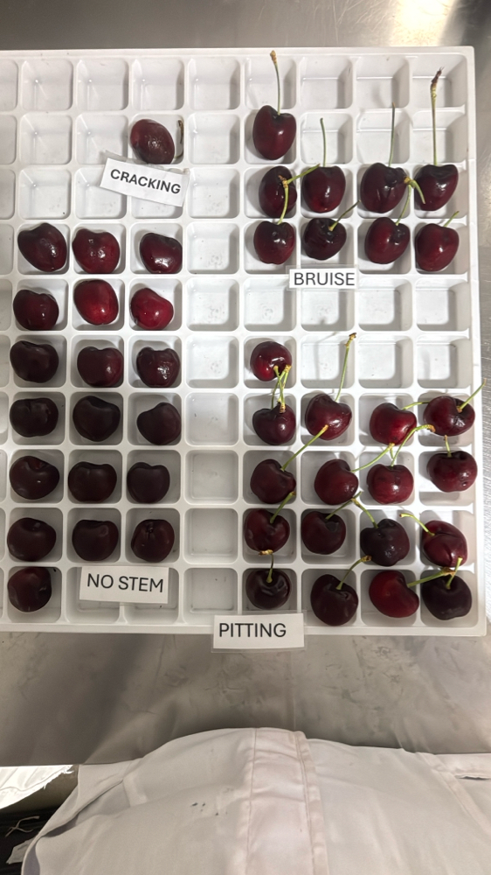 | 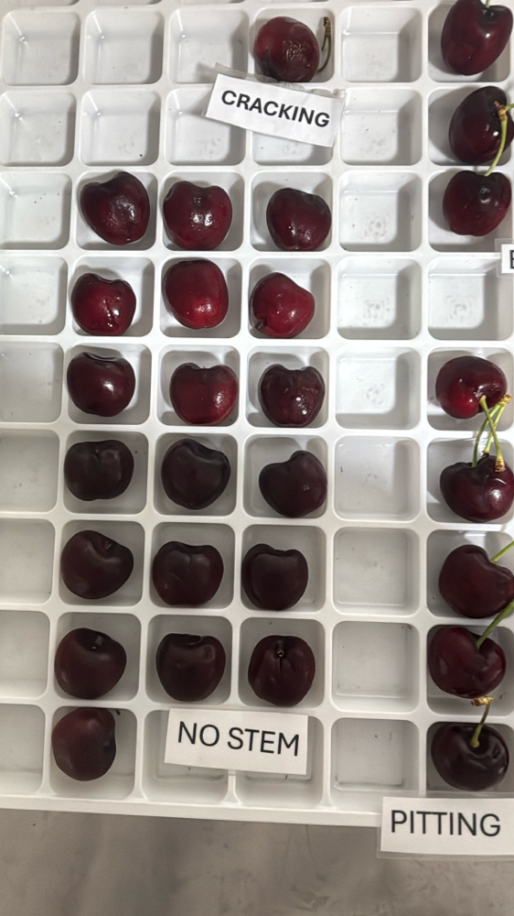

|  |  |  |  |  |  |  |  |  |  |  |  |
| --- | --- | --- | --- | --- | --- | --- | --- | --- | --- | --- | --- |
| Box Id | Soft | Wound | Bruise | Stain | Cracking | No Stem | Pitting | Decay | Avg Brix | Open | Firmness |
| 40829938 | 0 % | 1 % | 4 % | 1 % | 2 % | 10 % | 21 % | 0 % | 19.440000 | GOOD | GOOD |

Open

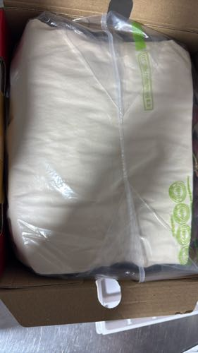 | 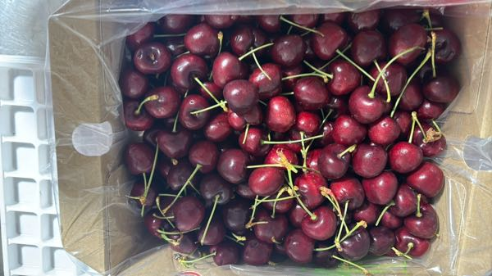 | 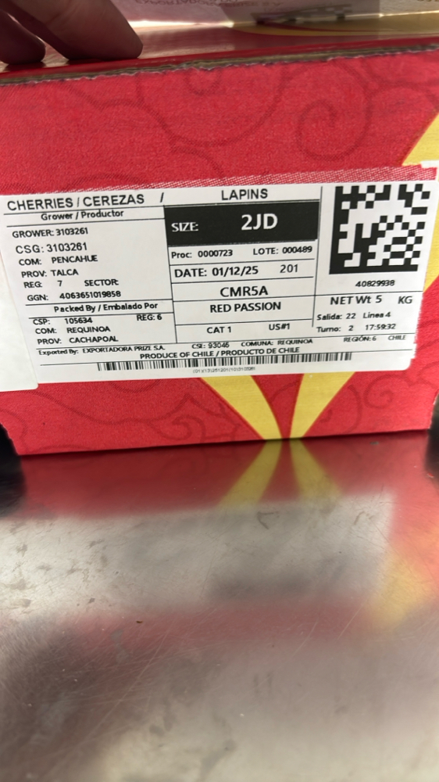

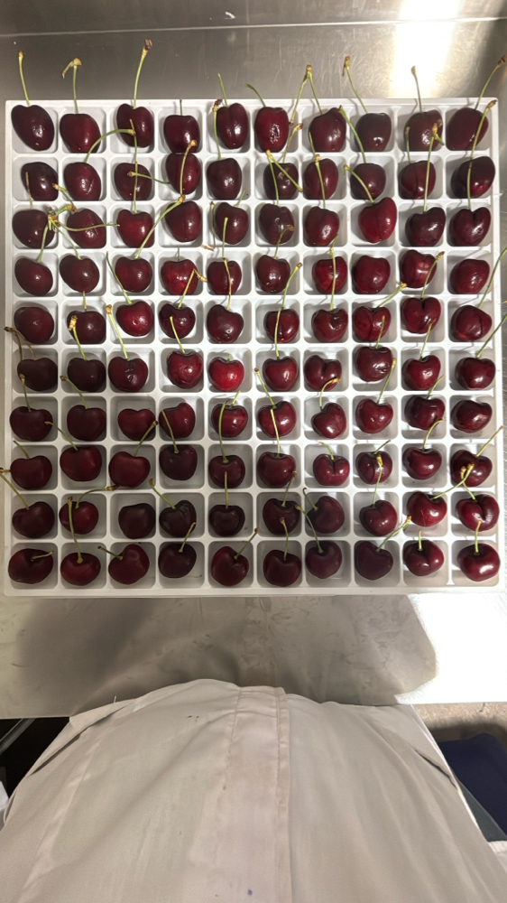 | 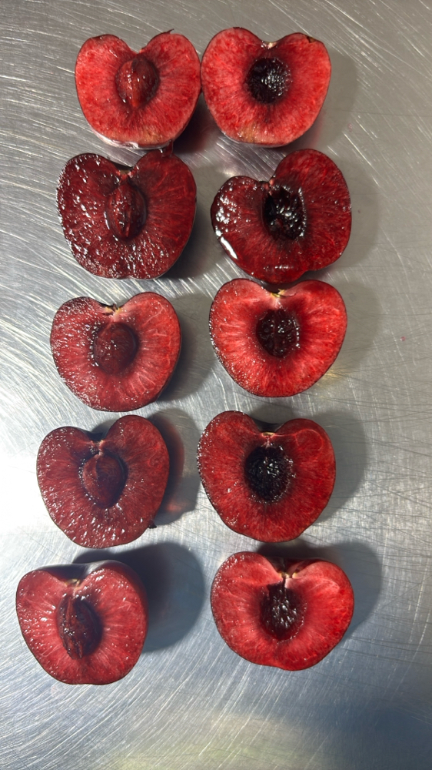 | 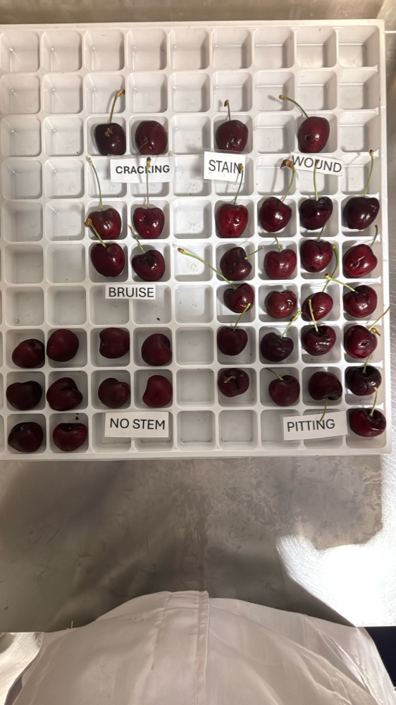 | 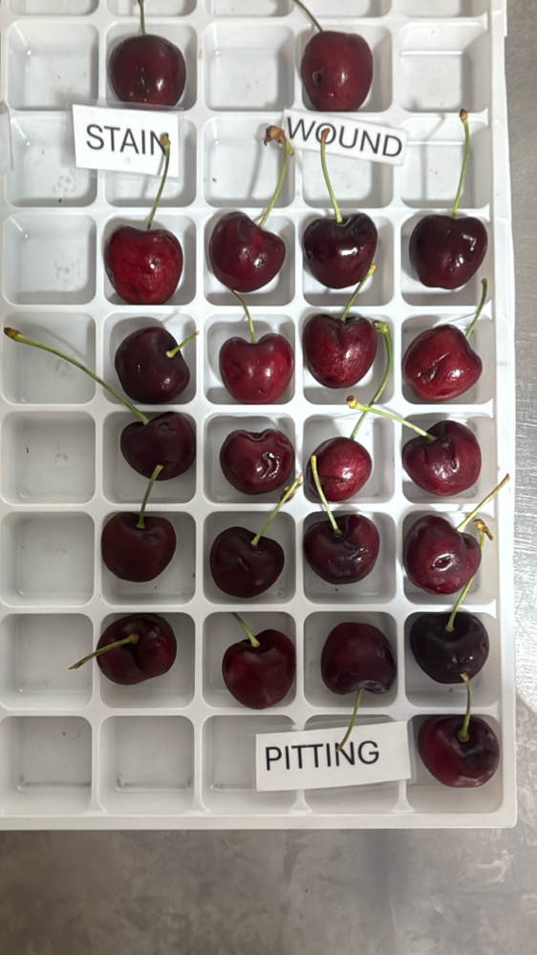

|  |  |  |  |  |  |  |  |  |  |  |  |
| --- | --- | --- | --- | --- | --- | --- | --- | --- | --- | --- | --- |
| Box Id | Soft | Wound | Bruise | Stain | Cracking | No Stem | Pitting | Decay | Avg Brix | Open | Firmness |
| 40971699 | 0 % | 1 % | 0 % | 0 % | 1 % | 2 % | 24 % | 0 % | 16.160000 | GOOD | GOOD |

Open

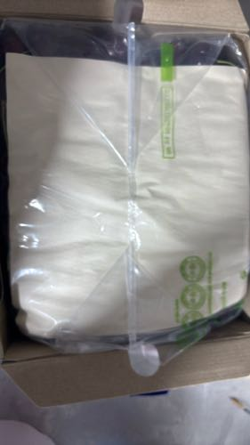 | 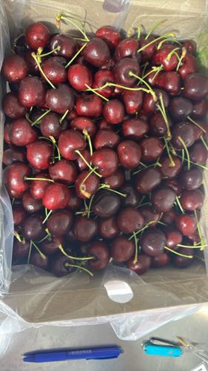 | 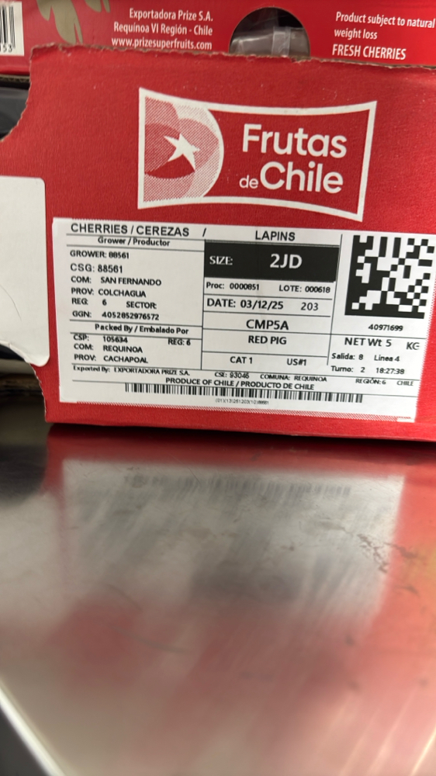

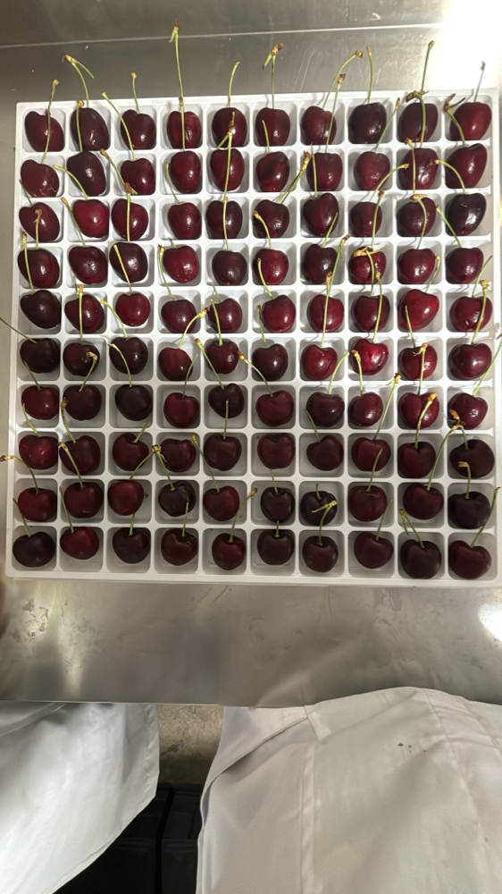 | 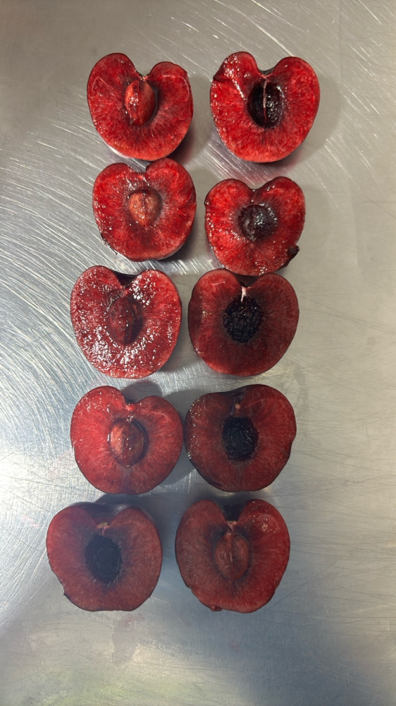 | 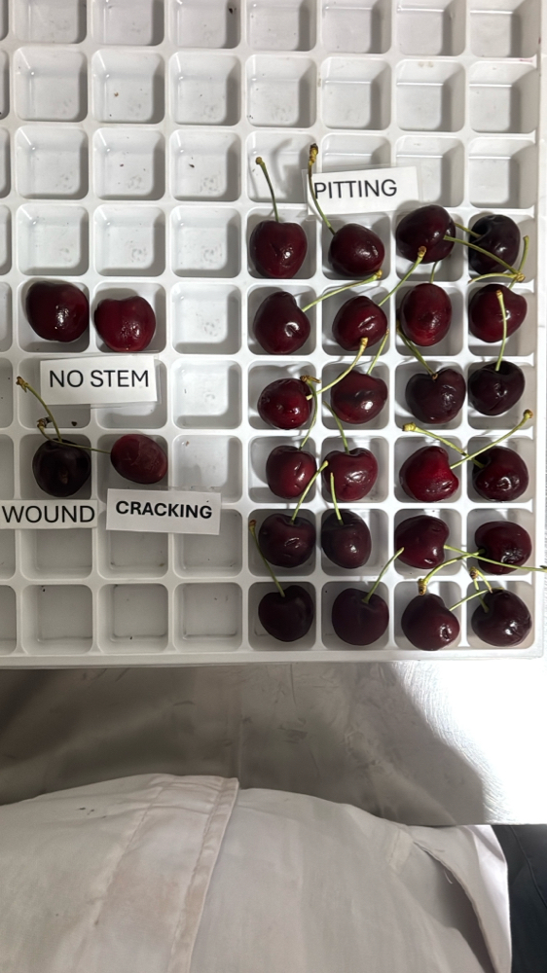 | 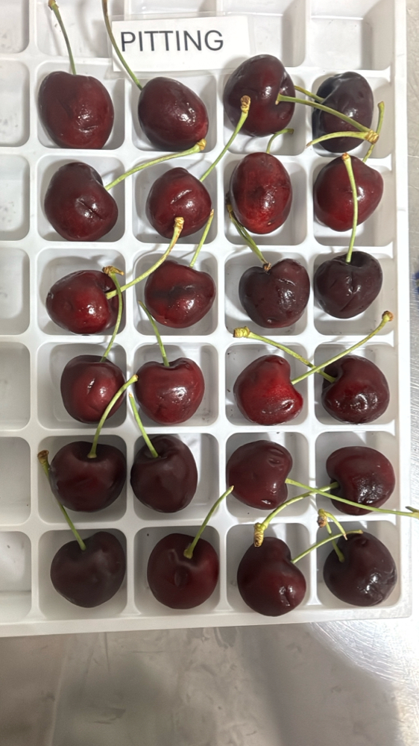

|  |  |  |  |  |  |  |  |  |  |  |  |
| --- | --- | --- | --- | --- | --- | --- | --- | --- | --- | --- | --- |
| Box Id | Soft | Wound | Bruise | Stain | Cracking | No Stem | Pitting | Decay | Avg Brix | Open | Firmness |
| 30597019 | 0 % | 4 % | 1 % | 0 % | 0 % | 8 % | 12 % | 2 % | 17.680000 | GOOD | GOOD |

Open

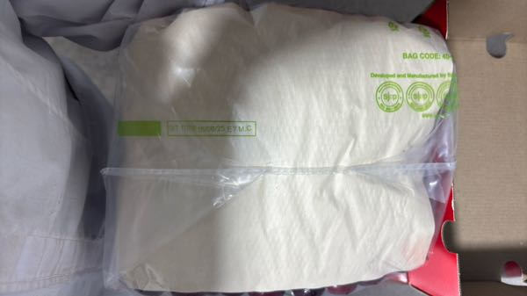 | 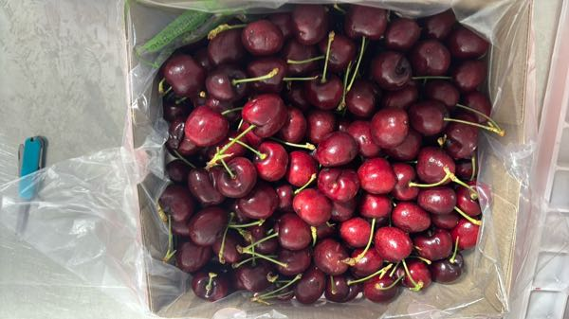 | 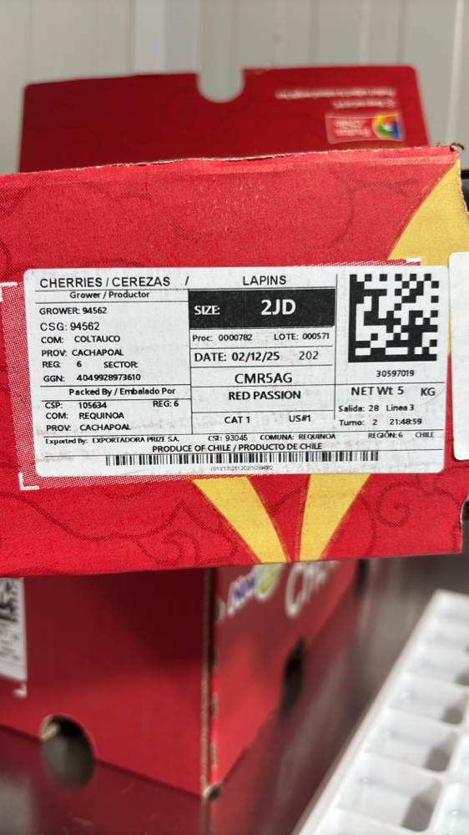

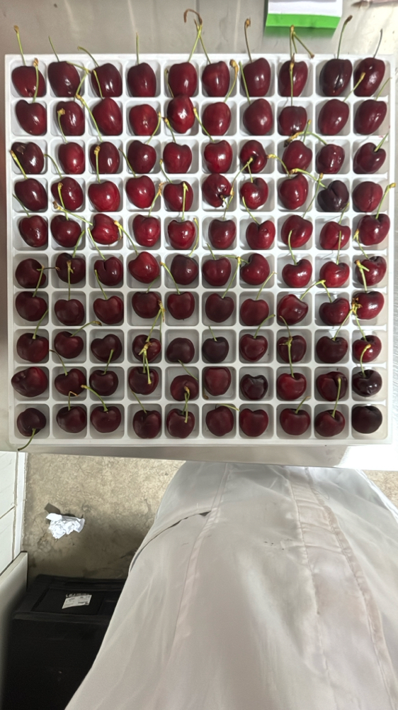 | 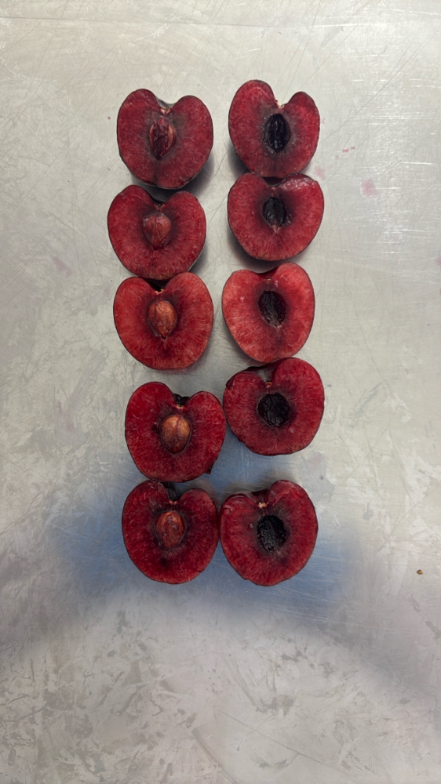 | 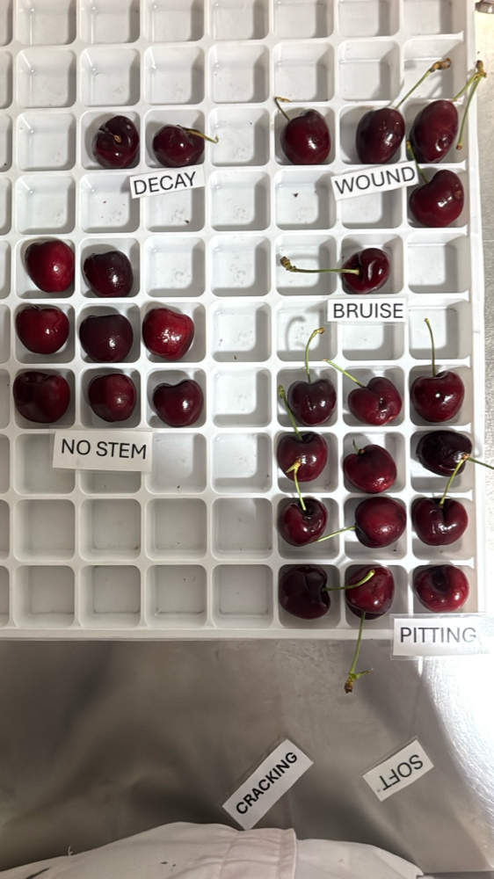 | 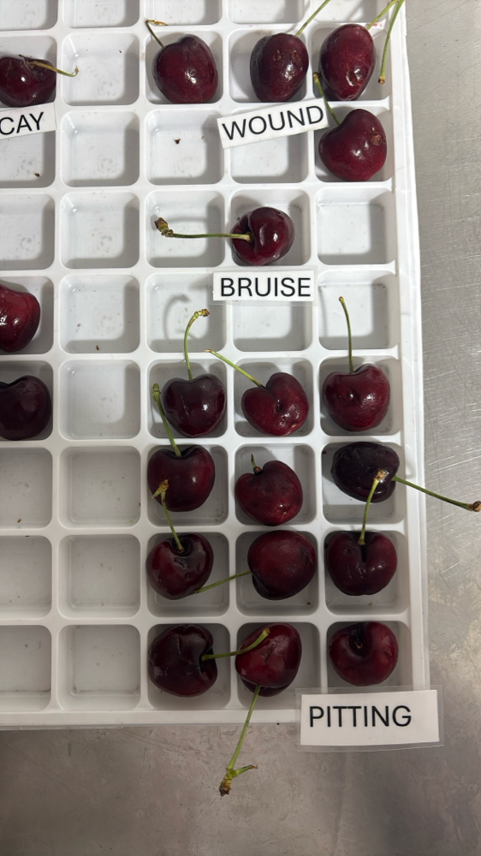

|  |  |  |  |  |  |  |  |  |  |  |  |
| --- | --- | --- | --- | --- | --- | --- | --- | --- | --- | --- | --- |
| Box Id | Soft | Wound | Bruise | Stain | Cracking | No Stem | Pitting | Decay | Avg Brix | Open | Firmness |
| 41075084 | 2 % | 0 % | 0 % | 0 % | 0 % | 5 % | 13 % | 0 % | 17.320000 | GOOD | GOOD |

Open

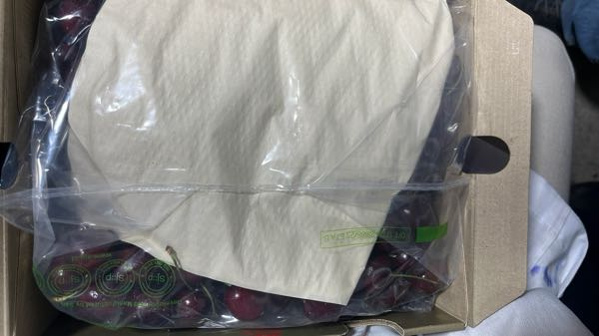 | 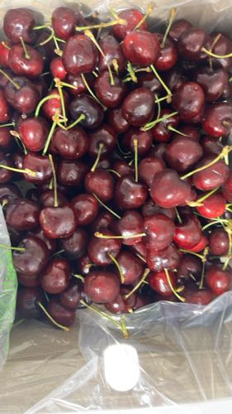 | 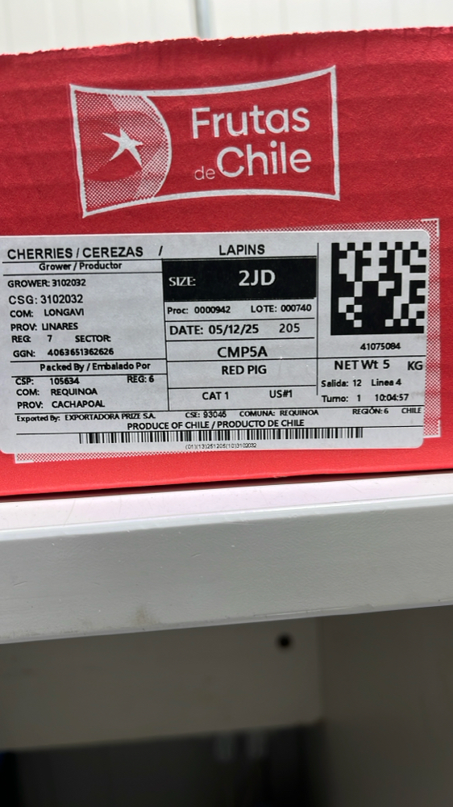

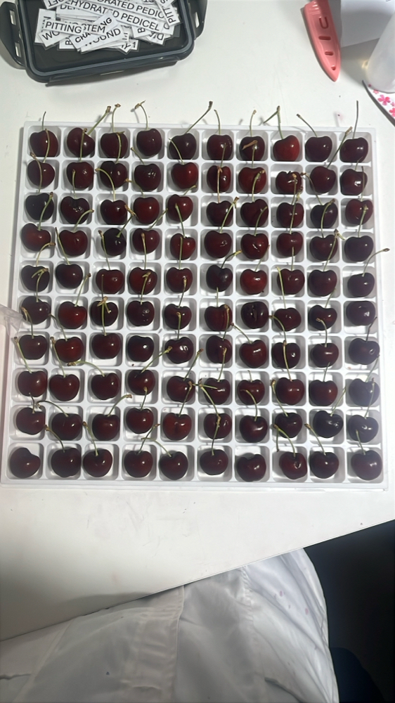 | 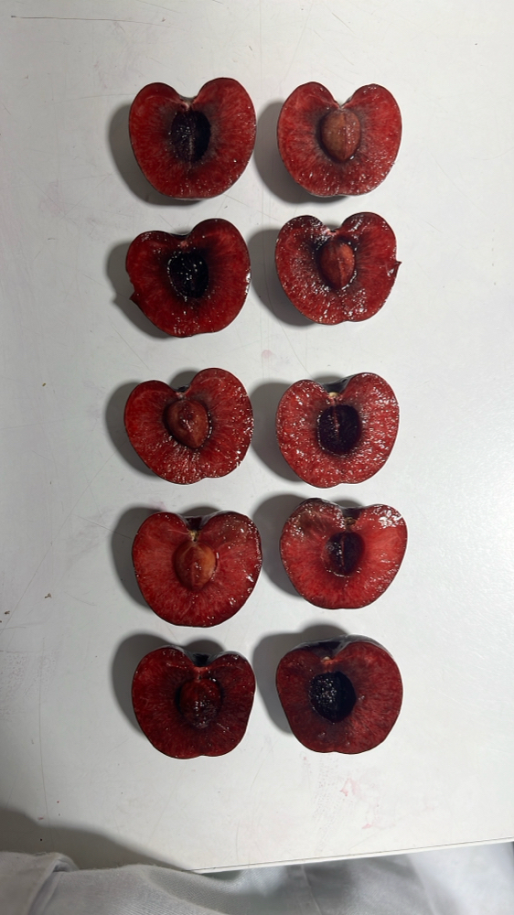 | 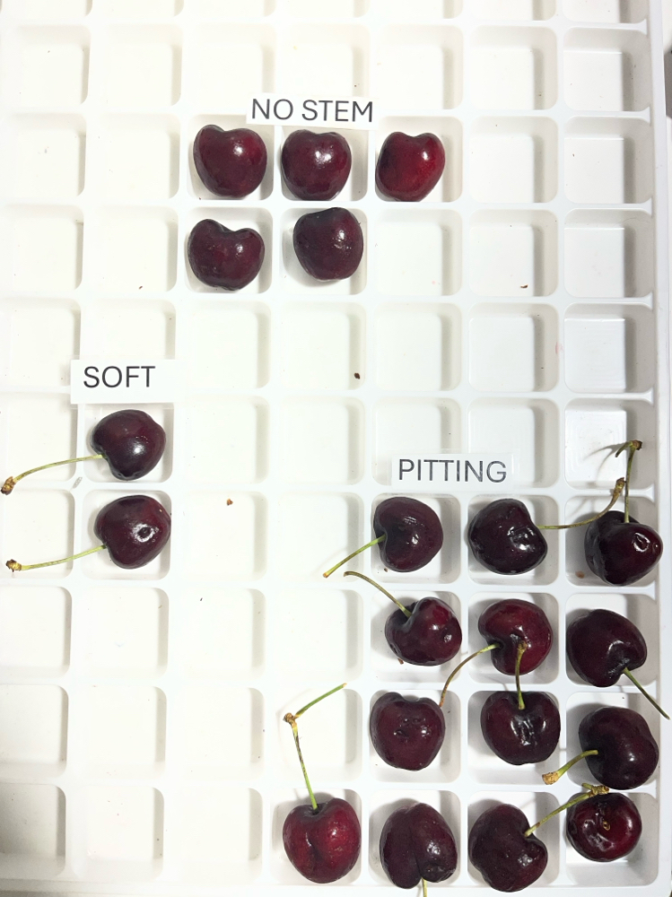 | 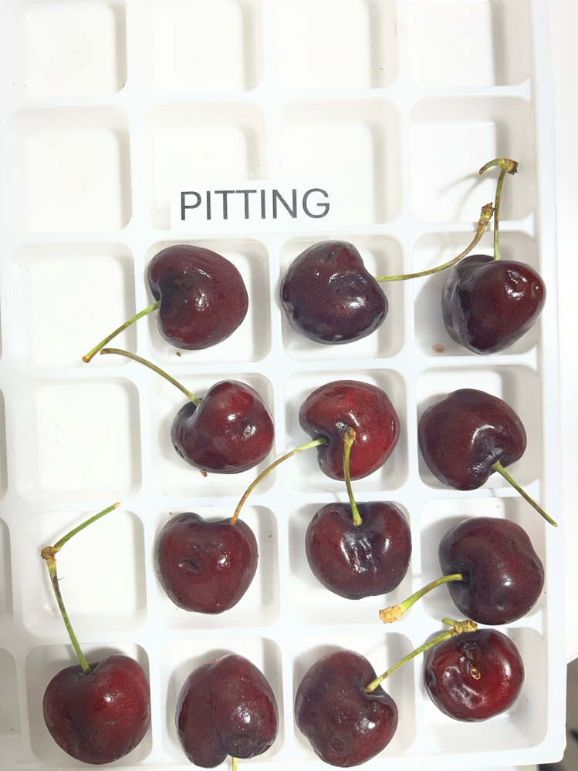

|  |  |  |  |  |  |  |  |  |  |  |  |
| --- | --- | --- | --- | --- | --- | --- | --- | --- | --- | --- | --- |
| Box Id | Soft | Wound | Bruise | Stain | Cracking | No Stem | Pitting | Decay | Avg Brix | Open | Firmness |
| 40989371 | 0 % | 0 % | 0 % | 0 % | 1 % | 6 % | 10 % | 0 % | 18.240000 | GOOD | GOOD |

Open

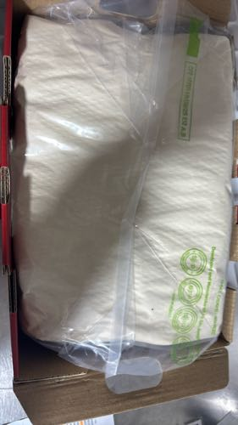 | 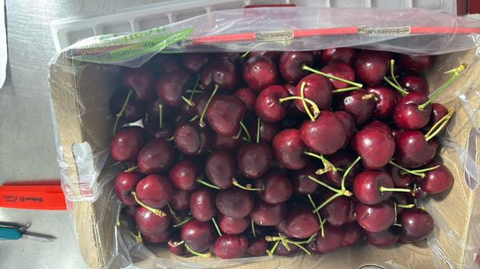 | 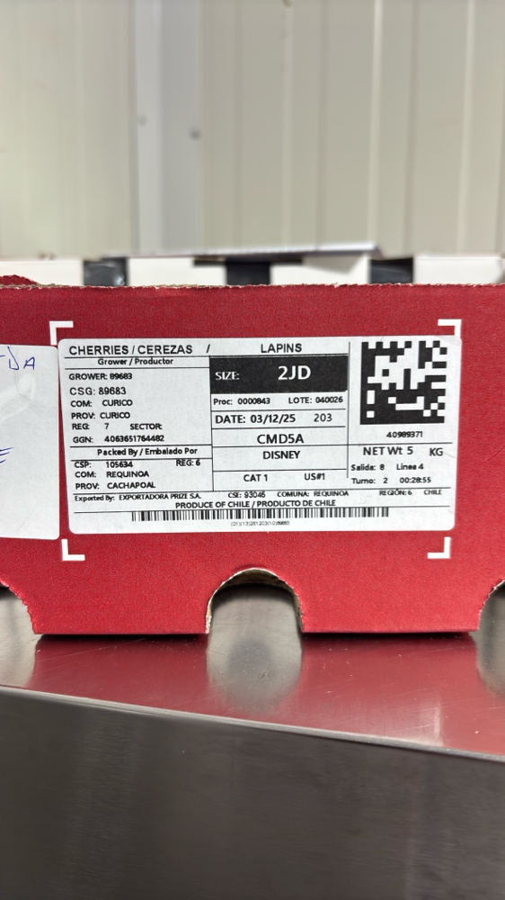

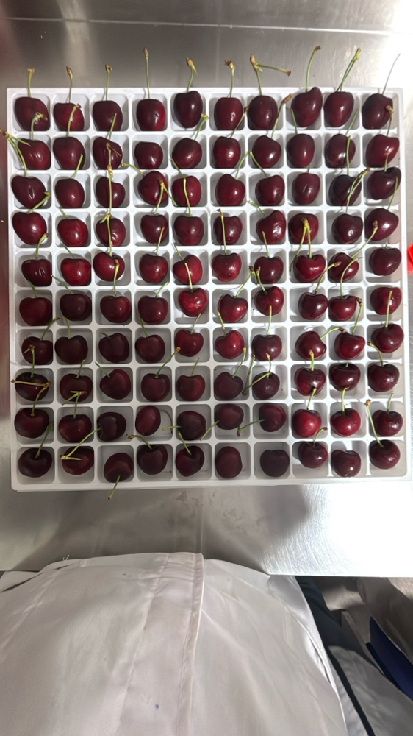 | 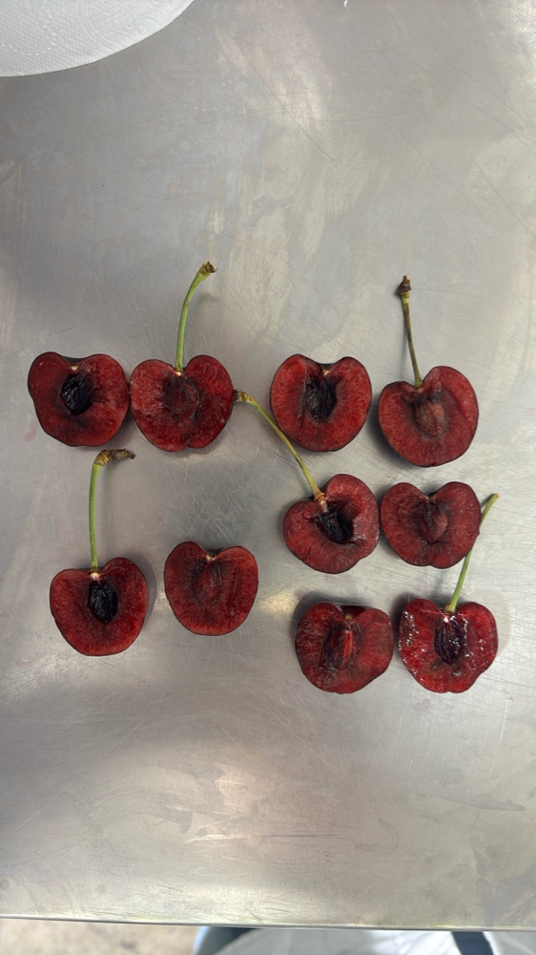 | 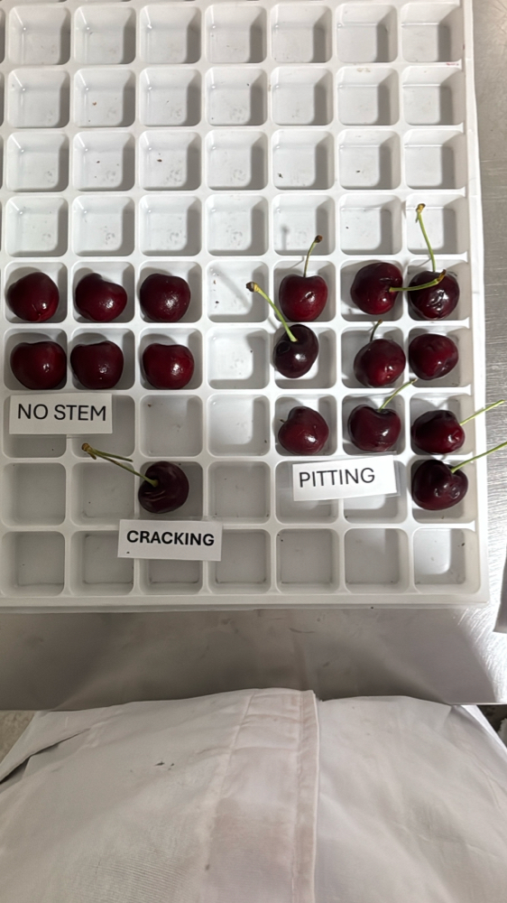 |

|  |  |  |  |  |  |  |  |  |  |  |  |
| --- | --- | --- | --- | --- | --- | --- | --- | --- | --- | --- | --- |
| Box Id | Soft | Wound | Bruise | Stain | Cracking | No Stem | Pitting | Decay | Avg Brix | Open | Firmness |
| 41148983 | 0 % | 0 % | 0 % | 0 % | 1 % | 9 % | 15 % | 0 % | 17.640000 | GOOD | GOOD |

Open

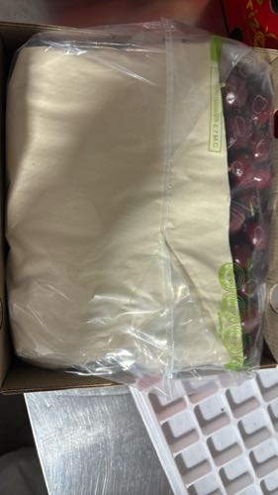 | 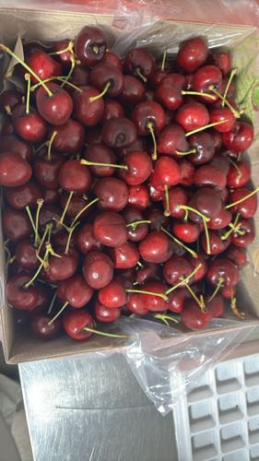 | 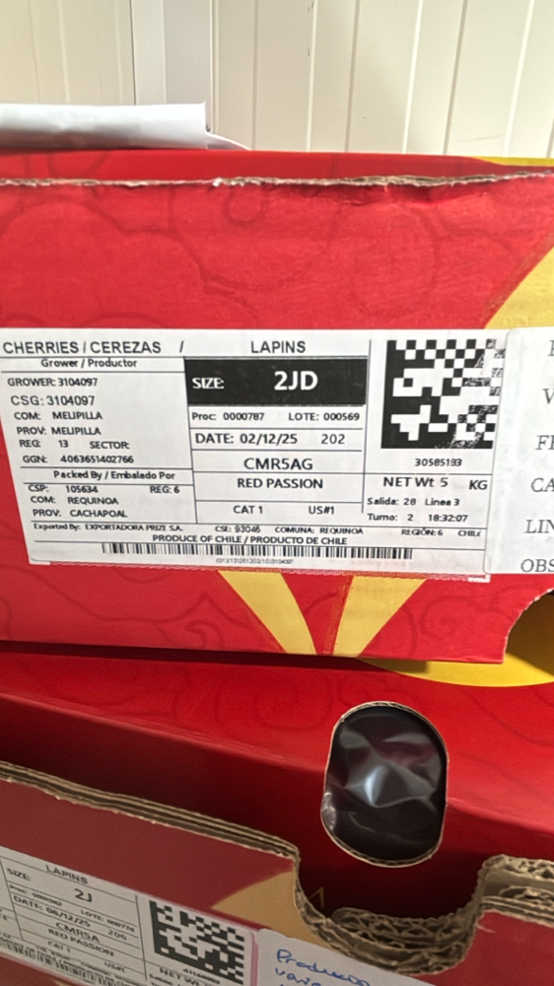

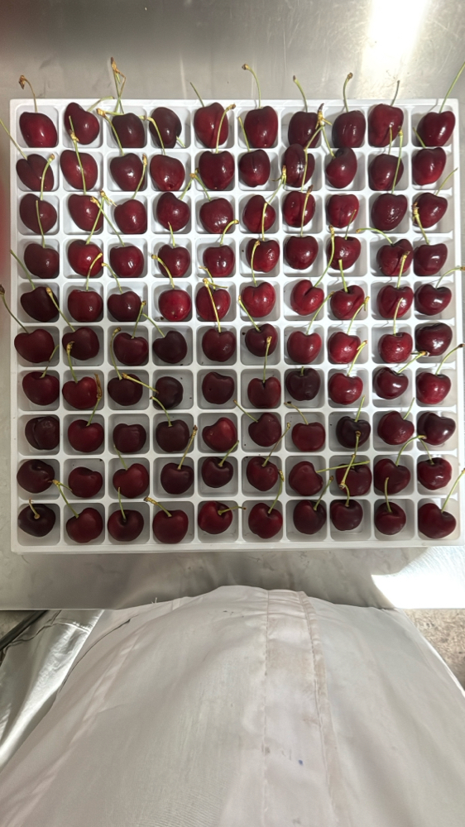 | 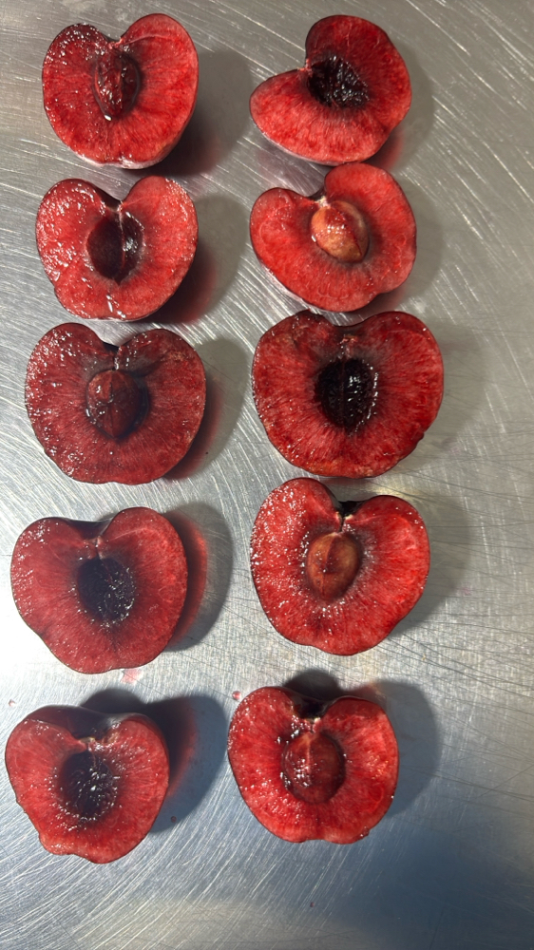 | 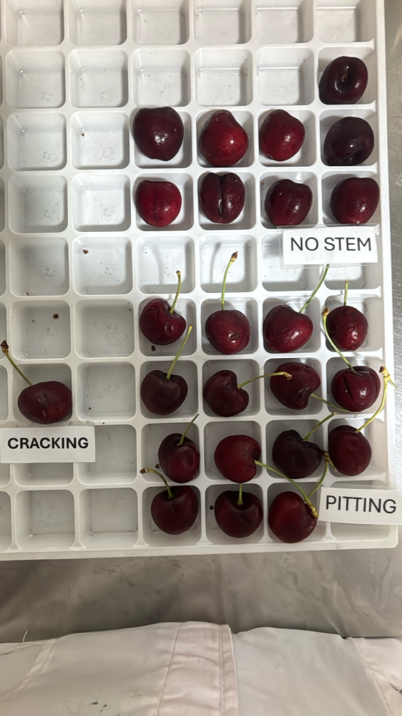 |

|  |  |  |  |  |  |  |  |  |  |  |  |
| --- | --- | --- | --- | --- | --- | --- | --- | --- | --- | --- | --- |
| Box Id | Soft | Wound | Bruise | Stain | Cracking | No Stem | Pitting | Decay | Avg Brix | Open | Firmness |
| 30395715 | 1 % | 0 % | 7 % | 3 % | 0 % | 19 % | 18 % | 0 % | 17.960000 | GOOD | GOOD |

Open

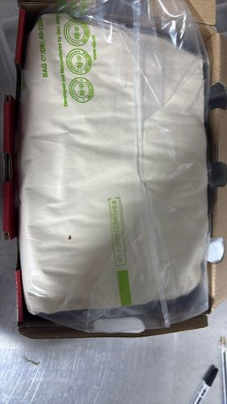 | 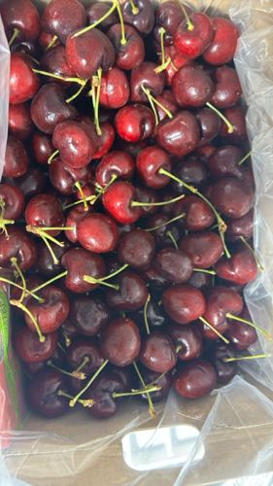 | 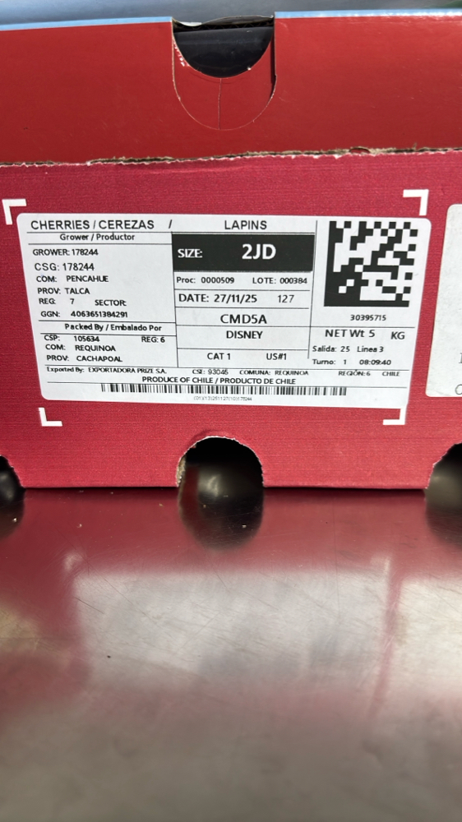

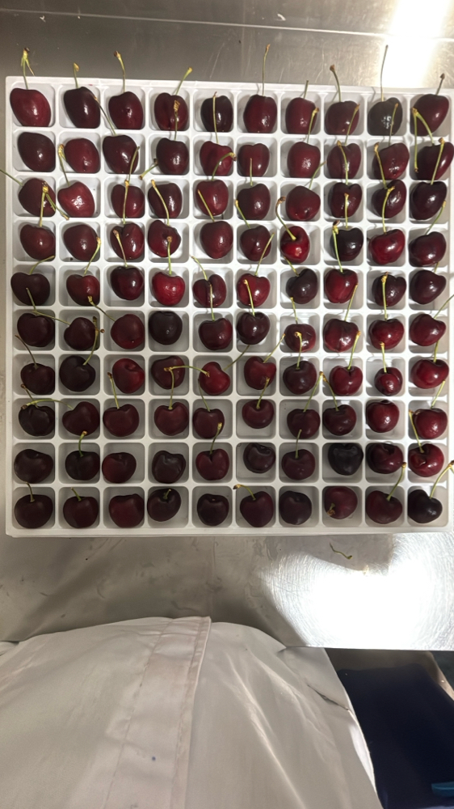 | 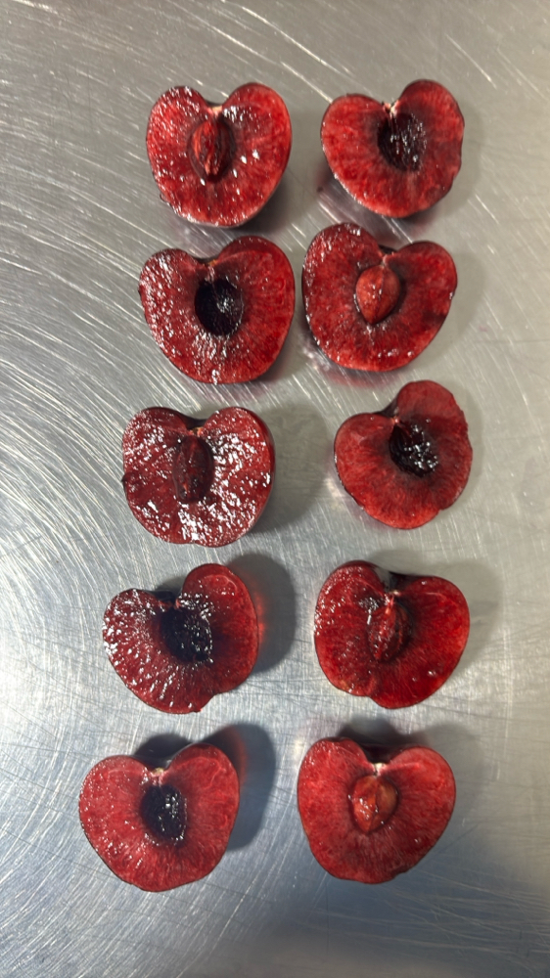 | 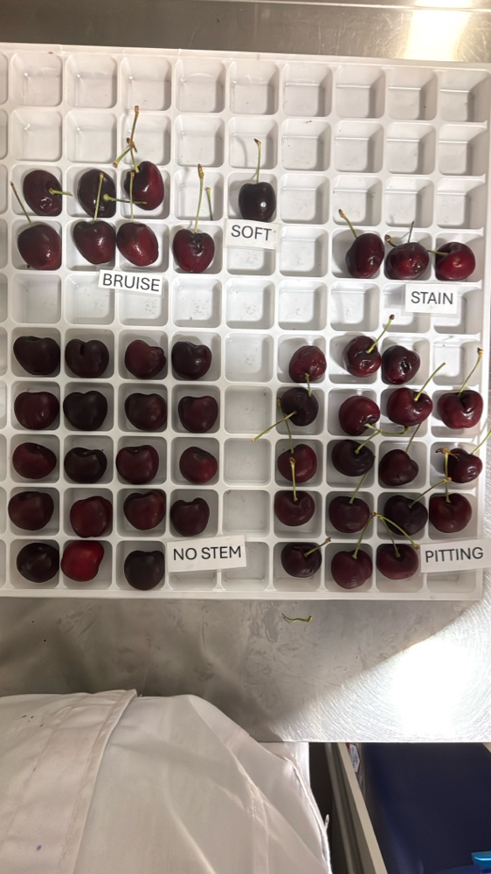 | 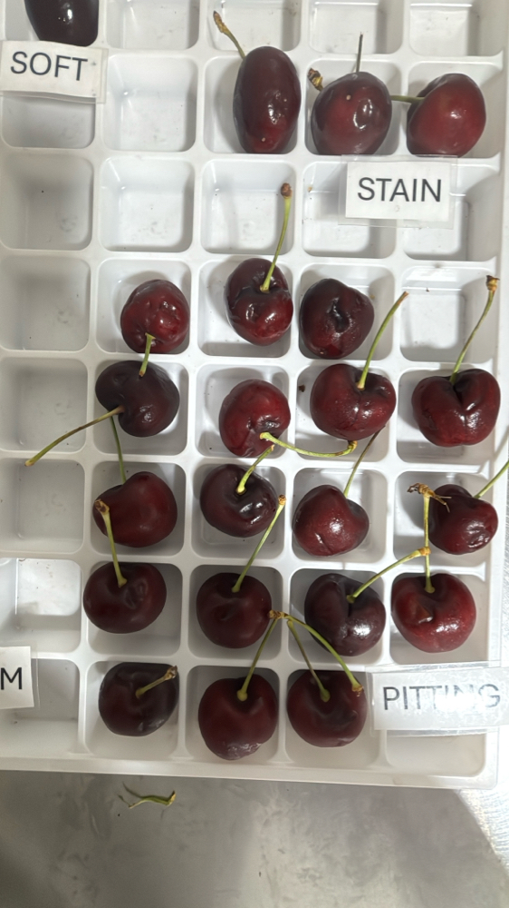

|  |  |  |  |  |  |  |  |  |  |  |  |
| --- | --- | --- | --- | --- | --- | --- | --- | --- | --- | --- | --- |
| Box Id | Soft | Wound | Bruise | Stain | Cracking | No Stem | Pitting | Decay | Avg Brix | Open | Firmness |
| 30796693 | 0 % | 0 % | 0 % | 2 % | 1 % | 9 % | 22 % | 0 % | 18.760000 | GOOD | GOOD |

Open

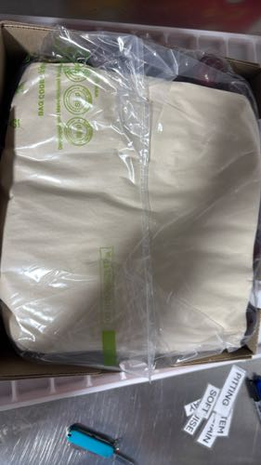 | 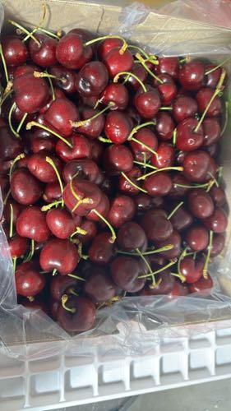 | 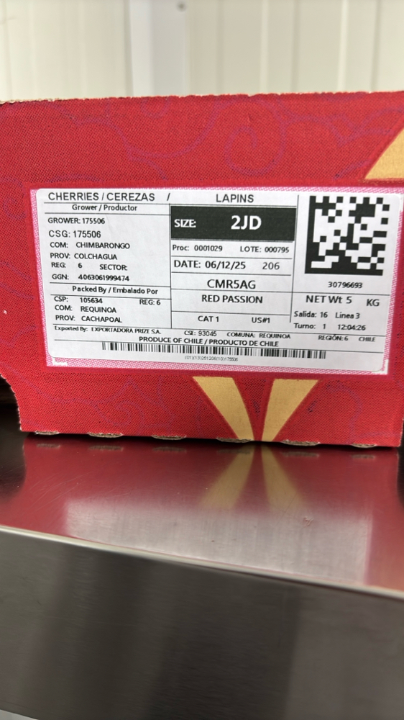

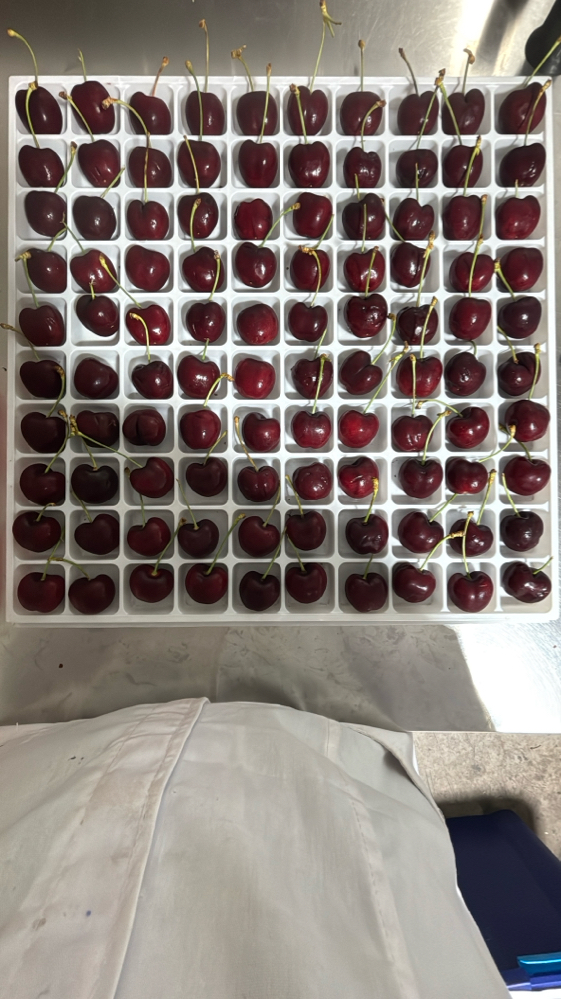 | 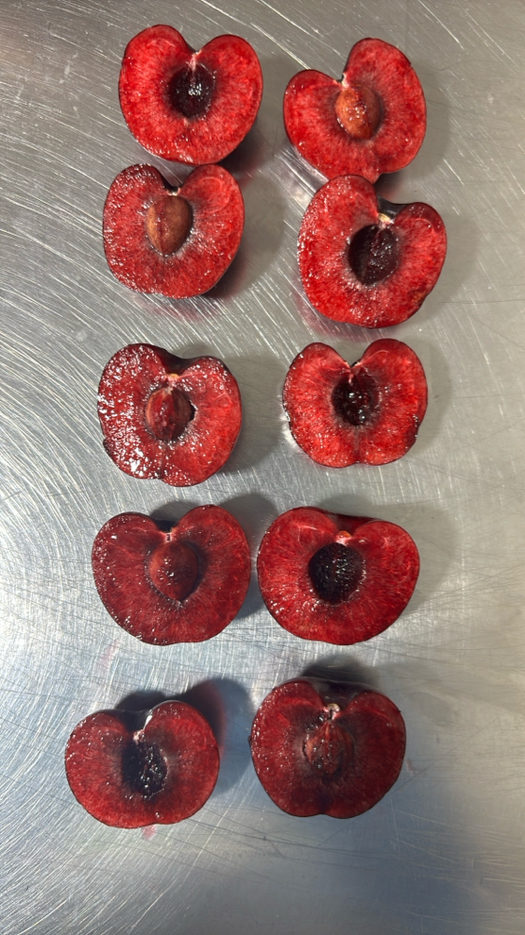 | 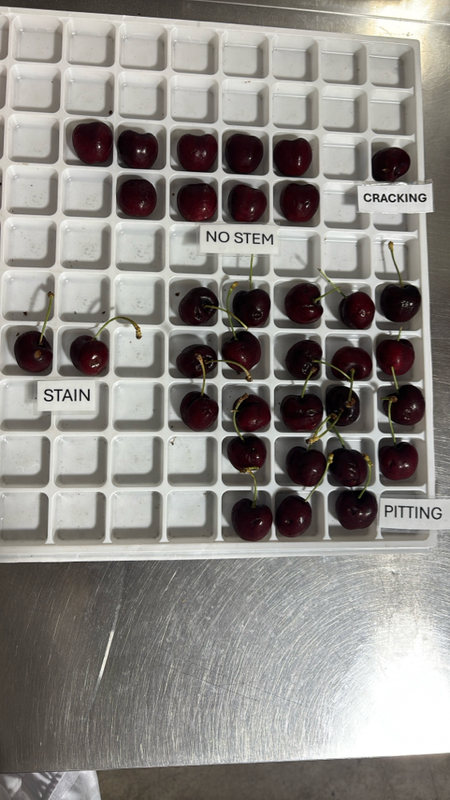 | 